Ultimo Community Centre access information
Contents
About Ultimo Community Centre 1
Getting to Ultimo Community Centre 1
Public transport 1
Driving or parking 2
Taxis and private vehicles 2
Entrance 2
Customer service 3
Toilets 3
Change and shower facilities 3
Elevators, stairs and passageways 3
Audio communication 4
Little Bridge Hall 4
Kitchenette 5
Indoor court 5
Outdoor court 1 – level 2 6
Outdoor court 2 6
Find out more 7

About Ultimo Community Centre
Ultimo Community Centre (UCC) offers 1 indoor multipurpose sports court, 1 indoor multipurpose hall, 2 outdoor multipurpose courts, ping pong tables and courtyard as well as a library, arts and crafts room, child care and meeting rooms.

Getting to Ultimo Community Centre

Public transport
There are 2 bus stops nearby on Harris Street. One is 190 metres away on the western side of Harris Street, and the other is 250 metres away on the eastern side of Harris Street. Bus stops are serviced by route 501 that travels to Ryde or Railway Square.
Exhibition Centre light rail station is 400 metres away and serviced by L1 line travelling to Dulwich Hill or Central. Access to Exhibition Centre light rail station is via lift at the Ian Thorpe Aquatic Centre.
There is no train station near UCC. Central train station is 1.5 kilometres away.
To plan your trip, visit Transport for NSW or call 131 500.
The Village2Village community transport bus operates Thursdays and Fridays. The route from Broadway to Woolloomooloo is via Sydney CBD, and stops outside UCC on William Henry Street near the corner of Harris Street.

Driving or parking
There is a set-down area for community busses at the front of UCC on Bulwara Road. Contact Ultimo Community Centre for more information on
02 9298 3111 or ultimocc@cityofsydney.nsw.gov.au.
There are 2 dedicated on-site accessible parking spaces at UCC. Contact centre staff to confirm availability.
The nearest on-street mobility car parking is 250 metres away on Macarthur Street, southern side, east of Bulwara Road.

Taxis and private vehicles
There is a set down area for small buses, cars and taxis at the front of UCC on Bulwara Road.

Entrance
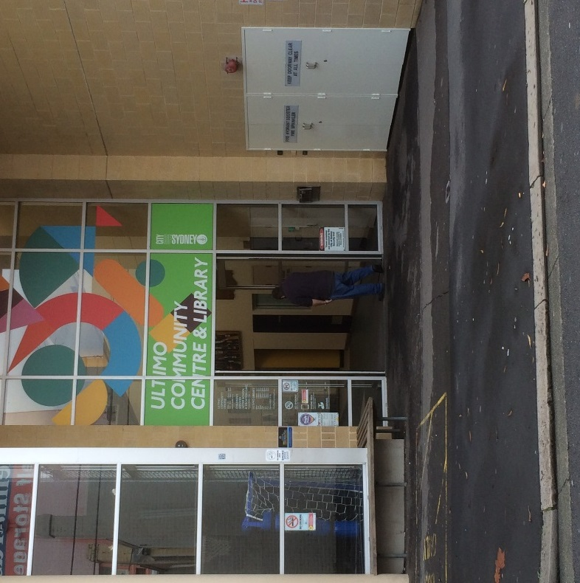
The pathway to the entrance is level, with uneven bitumen. There are no steps at the entrance to UCC and no handrail. Doors are heavy double swinging glass doors. Doors open to 1700mm wide. Doors remain open during operating hours.

Customer service
The customer service desk has a protruding bench integrated into the reception window for wheelchair users. However, there is no lower access to staff at the reception counter.

Toilets
There are 3 unisex accessible toilets at UCC on the ground floor near reception, in Little Bridge Hall and on level 1.
For the ground floor unisex accessible toilet, travel straight ahead from the entrance and the toilet is on the right-hand side before reaching the reception desk. The toilet door is solid wood and heavy, hinged on the left-hand side and suspended from rails at the top of the door. Pull door to open. The entrance is 1090mm wide. Toilet is left-hand side transfer.
For the level 1 unisex accessible toilet, turn left at the elevator, travel down the hallway. The toilet is on the left-hand side past the women’s toilet. The entrance is level. The door is solid wood and heavy, hinged on the right-hand side and suspended from rails at the top of the door. Pull door to open. Entrance is 1090mm wide. Toilet is left-hand side transfer.
Access to the unisex accessible toilet in Little Bridge Hall is described below.
There are no ambulant toilets at UCC.

Change and shower facilities
The ground floor unisex accessible toilet includes a shower. Travel straight ahead from the entrance and the toilet is on the right-hand side before reaching the reception desk. The door is solid wood and heavy, hinged on the left-hand side and suspended from rails at the top of the door. Pull door to open. Entrance is 1090mm wide. The shower is level with the ground, offers handrails and a height adjustable shower head. Shower controls are reachable from a seated position. There is no bench available.
There are no ambulant change or shower facilities at UCC.

Elevators, stairs and passageways
UCC offers lift access to 3 of 4 floors. For the lift, travel straight ahead from the entrance, past the reception desk and the lift is on the right-hand side, next to the stairs.
Control buttons are on the right-hand side and are reachable from a seated position. Buttons are illuminated and include braille.
Lift doors open to 890mm wide. There is a handrail on the left-hand side only.
There are no audio announcements in the lift. There is no circulation space in the lift and no mirror. The lift travels to basement level, ground level, level 1 for library and meeting rooms, level 2 for child care and outdoor court 1.
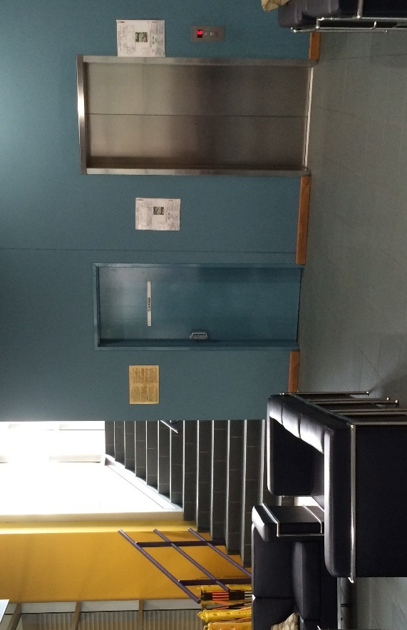
Stairs at UCC lead to level 1 library and meeting rooms. To access the stairs, travel straight ahead from the entrance, past the reception window and the stairs are on the right-hand side, directly next to the lift. There are 2 flights of stairs each with 14 steps, 28 steps in total. Stairs are 1640mm wide with handrails on left and right-hand sides. Both handrails are not continuous. Stairs include nosings (non-slip edges). There are no tactile ground surface indicators around the stairs.

Audio communication
There is a hearing loop in Little Bridge Hall only.

Little Bridge Hall
Access to Little Bridge Hall is on the ground floor. From the entrance, travel straight ahead, past the reception desk and exit through the glass doors to the courtyard. Travel straight ahead past ping pong tables and the entrance to Little Bridge Hall is on the right-hand side.
The doors are solid wood and the single door opens to 850mm wide, both doors open to 1700mm wide. Single door remains open during operating hours.
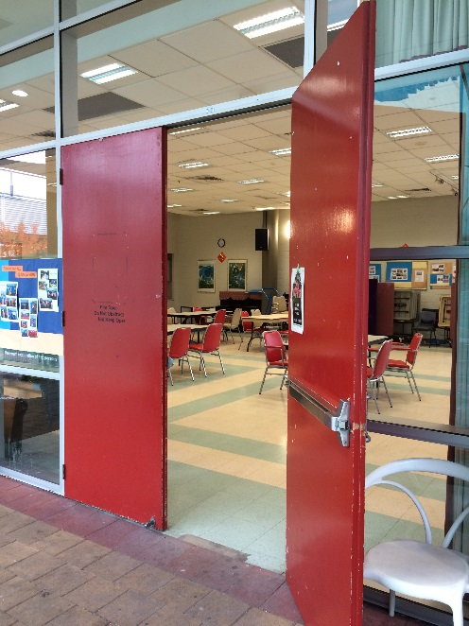
The hall offers flexible spectator seating, depending on how the hall is arranged.
For the unisex accessible toilet, from the entrance to the hall turn left and travel towards the hallway next to the kitchenette. Travel down the hallway, and the toilet is on the right-hand side. The door is solid wood and heavy, hinged on the right-hand side and suspended from rails at the top of the door. Pull door to open. The entrance is 1090mm wide. Toilet is left-hand side transfer.

Kitchenette
Little Bridge Hall offers a kitchenette. Entrance to the kitchenette is level with the ground.
There is no legroom available at benches and kitchen controls are not reachable from a seated position.

Indoor court
To access the indoor court from the main pedestrian entrance, go straight ahead past the reception desk and through the glass doors into the courtyard. The doors include a small lip on the ground at the doorway as the ground surface transitions to brick. Turn left and travel across the courtyard towards the entrance to the indoor court. Pathway is level with ground.
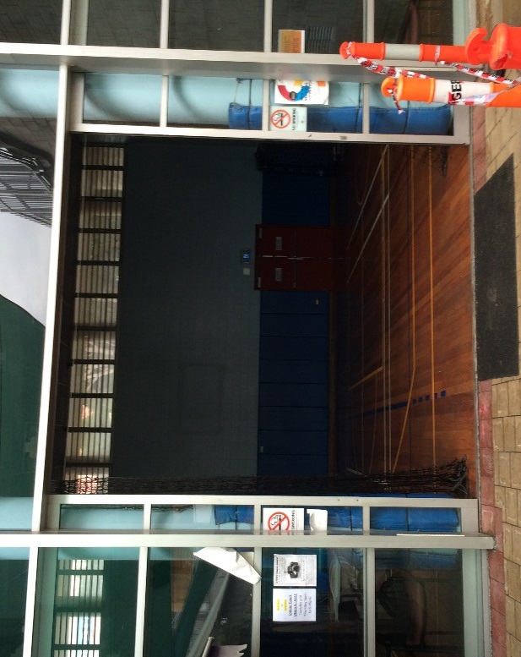
The entrance to the indoor court is double sliding glass doors. Doors remain open during operating hours. Entrance is 2740mm wide.
Indoor court potentially allows for mixed accessible spectator seating, depending on the arrangement of chairs and equipment on the court.
There is no hearing loop available in the indoor court.

Outdoor court 1 – level 2
To access outdoor court 1, travel in the lift to level 2. Exit the lift, turn left and travel towards the glass door. Push to exit through glass door, which opens to 790mm wide. Glass door remains unlocked during operating hours. Travel down the ramp. The ramp is 1560mm wide and has continuous rails and gutters. At the end of the ramp turn left to enter outdoor court 1.
The entrance is through a mesh gate. Push gate to open. Entrance to court is 1600mm wide and remains unlocked during operating hours.
The outdoor court offers some space for mixed accessible spectator seating at the back of the court, above William Henry Street.

Outdoor court 2
Access to outdoor court 2 on level 2 is via stairs only. To access the outdoor court 2 on level 2, take the lift to level 2.
Exit the lift, turn left and travel towards the glass door. Push to exit through glass door, which opens to 790mm wide. Glass door remains unlocked during operating hours. Travel straight ahead to stairs on right-hand side. There are 2 flights of stairs, 24 steps in total which are 1560mm wide. Stairs have handrails on both sides. Stairs do not have nosings (non-slip edges) and no tactile ground surface indicators.
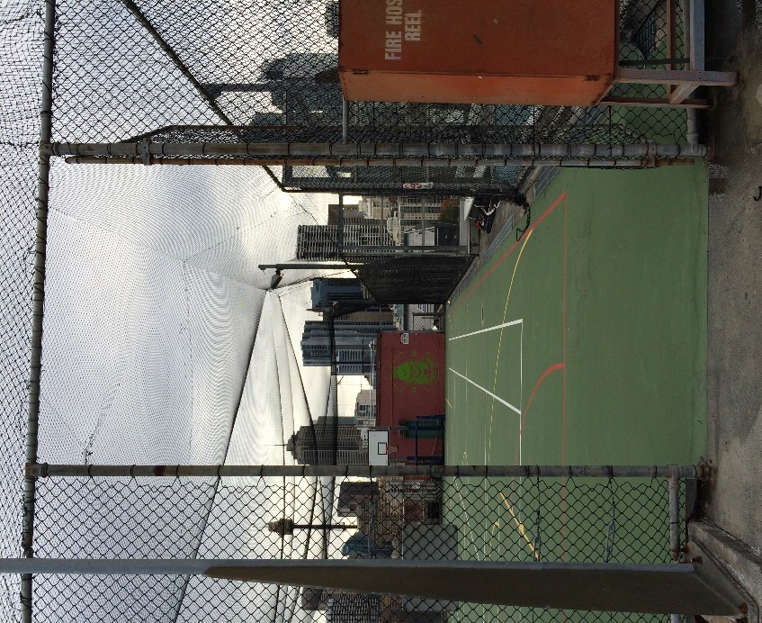
The entrance to outdoor court 2 is through a mesh gate. Push gate to open. Entrance to the court is 1600mm wide and remains unlocked during operating hours.

Find out more
To find out more about the Ultimo Community Centre, and the activities are on offer, contact Ultimo Community Centre staff on 02 9298 3111 or ultimocc@cityofsydney.nsw.gov.au.

