Attachment B
Engagement Report

Engagement Report
Inclusion (Disability) Action Plan 2021-2025
October 2020

Contents
Background 3
Engagement summary 4
Engagement activities 5
Survey and workshop findings 7
Appendices 28

Background
Our vision is for an inclusive and accessible city, where people with disability have equitable opportunities to participate in social and cultural life, in meaningful employment and decision-making processes.
An inclusive city is one where people with disability are viewed positively by the wider community and acknowledged and celebrated for their diverse contributions and experiences.
The City is developing our fifth Inclusion (Disability) Action Plan. In doing this we have thought about the barriers that people might face in our community.
The plan will explain the changes we can make to improve the lives of people with disability in our community.
The plan will include actions in the following categories:
- Community attitudes and behaviours towards people with disability;
- How people with disability live in and get around the community;
- Jobs for people with disability, and;
- How people with disability access council services and information.

Engagement summary

From 31 August to 9 October 2020, we asked the community for feedback on how we can create a more inclusive city.
This consultation provided people with disability, people with mental health conditions, and people with caring responsibilities the opportunity to help shape the City’s fifth Inclusion (Disability) Action plan and be involved in creating a more inclusive city.
Consultation activities included an online survey, online workshops, phone interviews and written submissions.

Purpose of the engagement
The NSW Disability Inclusion Act 2014 requires councils consult with people with disability to inform the development of their disability inclusion action plans. The purpose of the engagement was to:
- determine what issues and actions are of importance and should be addressed in the action plan
- gather feedback from stakeholders, people with disability, people with caring responsibilities and people with mental health conditions

Outcomes from the engagement
We received a total of 170 submissions (via Survey Monkey, email and phone) during the public exhibition period.
The Sydney Your Say page was visited 377 times during the consultation period. The summary was downloaded 15 times. The easy read version of the summary was also downloaded 15 times.
We received one submission from the Sydney Opera House.
Snapshot of outcomes
Total | Description of activity
170 | Total submissions received
164 | Survey submissions
3 | Emailed submissions
3 | Submissions via phone
1 | Submissions received from state government agencies
377 | Sydney Your Say webpage visits
30 | Document downloads
41 | People attended 7 online workshops

Engagement activities

Overview of engagement activities
The City’s Inclusion (Disability) Advisory Panel were consulted to inform the engagement program.
A Sydney Your Say webpage was created, along with an online survey. There was a total of 164 responses to the survey.
Eight online workshops were held in September 2020. A total number of 41 attendees participated in these workshops.

Sydney Your Say webpage
The Sydney Your Say webpage, https://www.cityofsydney.nsw.gov.au/policy-planning-changes/help-us-create-more-inclusive-and-accessible-city-people-with-disability included an electronic copy the summary, survey, schedule for the workshops and other key information about the consultation.
There were a total of 1,011 unique page views on the consultation period, and 164 survey responses.

Workshops
A total of eight online workshops were held during September 2020.
City staff identified that the City’s previous Inclusion (Disability) Action Plans had primarily focused on the inclusion of people with physical, mobility and sensory disabilities. In order to identify initiatives that would create services, programs, events and systems that are inclusive of people with less visible disabilities the City consulted people with an intellectual disability and people with Autism.
The City worked with NSW Council for Intellectual Disability and Autism Spectrum Australia to recruit participants, design and facilitate the workshops.
Participant group | Workshop dates | Facilitated by | No. of attendees
Community  Open to people with disability, people with mental health conditions, people with caring responsibilities and members of the broader community. | 22 September  24 September | City of Sydney | 9
Sector  People working in disability services or peak organisations representing people with disability and or caring responsibilities | 30 September | City of Sydney | 7
People with Autism  Parents /carers of people with Autism, adults with Autism. | 23 September am  23 September pm | Aspect (Autism Spectrum Australia) | 16
People with intellectual disability | 29 September  1 October | NSW Council of Intellectual Disability | 11

Digital marketing

Sydney Your Say e-News
The consultation was included in the Sydney Your Say e-Newsletter for the 15 and 24 September (7,385 subscribers). This resulted in a total of 66 unique clicks to Sydney Your Say website relevant page.

Sydney City News story
A Sydney City News story was published on 2 September and resulted in 176 unique page views. This converted to 74 unique click throughs to the Sydney Your Say webpage.

Key stakeholder notification
An email was sent to 205 key stakeholders, including disability sector organisations and people with disability who have previously engaged with the City, inviting them to register for the workshops and or respond to the survey.
There were 60 unique opens from 33.71% of recipients, 22 people clicked a link and 4 people shared on Facebook or via email.

Facebook Advertising
Paid Facebook advertisements were run between 7 - 19 September, with a reach of 55,000 people, resulting in 717 landing page views which converted to 436 unique click throughs to the Sydney Your Say webpage.

LinkedIn Advertising
The linked in advertising resulted in 92 clicks and 44 clicks/likes and comments on the ad. This converted to 84 unique click throughs to the Sydney Your Say webpage.

Media release
A media release was published on 2 September 2020, resulting in the following media coverage on 3 September 2020.
- ABC Breakfast with Wendy Harmer and Robbie Buck - https://media.streem.com.au/player/yciAJ9
- ABC News online –https://www.abc.net.au/news/2020-09-03/sydney-morning-briefing-thursday-september-3/12622052?
- 2SER morning news bulletin
- City Hub - https://links.streem.com.au/city-hub-sydney-20200902-R8mPBlhZb4SV
- Down Syndrome Australia shared on Facebook.

Survey and workshop findings
The following sections outline key themes, issues and opportunities raised in the six workshops, followed by a summary of findings from the survey. The issues raised were generally consistent across the workshops and survey’s, with some richer detail provided by workshops.

Snapshot of people who answered the survey
This is a snapshot of key demographic information of people who responded to the survey. It is not representative of all people with disability, people with mental health issues or people with caring responsibilities.
164 people surveyed
85% completed the survey as individuals (not as an organisation or business)
55% a person with disability
40% a carer
32% a person with a mental health condition
51% live in the area
43% work locally
26% are visitors
75% identify as female
53% aged 40-59 years
28% aged 20-39 years
70% prefer council information via social media
84% prefer Facebook
45% prefer Instagram

Direction 1 - Community attitudes

Subjects/topics raised
People who answered the survey (73%) said there are either very negative or negative attitudes in the community towards people with mental health conditions.
51% of people who answered the survey said that there are neutral (sometime negative, sometimes positive) attitudes in the community towards people with disability.
In the workshops, there were mixed responses about attitudes towards people with disability. People with visible physical disabilities reported community attitudes generally improving, stereotypes and stigma still exists. People with invisible disabilities, such as Autism, explained there was a lack of awareness and understanding in the community.
We asked how the City can improve attitudes in the community towards people with disability and people with mental health conditions. Below is a table summarising the ideas and issues people raised, how many times it was raised, and a response from the City.
Idea or issue raised | Total | City of Sydney Response
More community and staff education and awareness about disability including invisible disabilities.  Key feedback:  - People with disability wanted more understanding and awareness of disability, including invisible disabilities.  - People with invisible disabilities face unique discrimination because others don’t perceive them as having a disability.  - An adult with Autism at a workshop explained:  “If I'm behaving in a strange way or speaking in a strange way it can be overwhelming sometimes to be in a public space and seeing all these glances and looks where it's clear people are making a negative judgment or even a little bit worried to share the same space with somebody who's behaving differently, like that. So I feel like accessing public spaces can be difficult in that way, in terms of, how do people read difference when they're not exposed to it in a visual way very often. And one of the ways that that can happen sort of naturally is by having specific events that encourage a lot of different sort of people to be in a public space, where people can see that, and sort of get used to being around different, diverse sort of people.” | 27 survey Responses.  Raised at all 7 workshops. | Feedback noted and addressed in Action 1 of plan:  Continue to implement a program of disability inclusion training for City of Sydney staff.
The City should lead by example and promote greater visibility and positive representation of people with disability.  Key feedback:  - Changing community attitudes and behaviours can be done through increased visibility and representation of people with disability in the workplace and community, and across council communications.  - Include more images of people with disability in City media, communications and publications, not just those related to disability.  - Promote the everyday stories of people with disability through social media. This will help to reduce stigma and raise awareness.  - Run programs that break down stigma around disability and mental health conditions such as a “you can’t ask that” style program. | 27 survey responses  Raised in all 7 workshops | Feedback noted and addressed in the below actions within the plan:  Action 2: Continue to provide community programming aimed at fostering positive community attitudes towards people with disability, including people with less visible disabilities and people with mental health conditions.  Action 3: Increase the usage of images of people with disability across City publications, digital platforms and media channels.
More community and staff education and awareness about mental health conditions.  There remains significant stigma towards people with mental health conditions. People wanted more understanding, less fear and better education to understand different types of mental health conditions (not just depression and anxiety). | 17 survey responses.  1 written submission. | Feedback noted and addressed in Action 1 of the plan:  Continue to implement a program of disability inclusion training for City of Sydney staff.  This program of training includes access to training for staff and managers on mental health.
Improve access in public spaces to shift community attitudes.  Key feedback:  - Barriers in physical environment contribute to negative community attitudes and behaviours. People without disability see people with disability struggling to access spaces independently, and this reinforces negative attitudes. In order to change attitudes towards people with disability, people with disability need to be visible in the community and perceived as independent and capable.  - Providing a more accessible built environment, and more inclusive and accessible events, programs and services is an effective way to do this, because if people with disability can genuinely participate without struggle then attitudes about what people with disability can do will shift.  - A workshop participant explained “the built environment can contribute to the feeling of hostility towards people with disability and the feeling of exclusion”. | 16 survey responses  Raised in 2 workshops | Feedback noted and addressed in Action 4 of the plan:  Continue to improve the accessibility of streets, footpaths, parks and open places through renewal programs, upgrades and new capital projects in compliance with the Inclusive and Accessible Public Domain Policy and Guidelines.
Provide more inclusive events and programs so people with disability are seen in the community.  Key feedback:  - Providing more opportunities for people with disability to attend events and program normalises disability as they’re seen more in the community.  - Full inclusion in all events and activities promotes acceptance and understanding  - One person explained in their survey response: “Making things more accessible and common place makes it normal for community to accept us.” | 16 survey responses.  1 phone consultation. | Feedback noted and addressed within Action 14 of the plan:  Continue to deliver a range of inclusive community, learning, sport and recreation programs and major events that ensure equitable access and participation for people with disability.

Direction 2 – Liveable Communities

Getting around our city
Approximately half of the people who answered the survey told us they find it difficult or very difficult to move around our city, access public facilities and buildings, and access parks, streets and public spaces.
People with disability told us there remain significant barriers in getting around the city. They explained that an accessible public domain is the critical factor that supports their independent access to employment, medical and government services, recreation and social and cultural activities.
We asked how we can make it easier for people to get around our city. Below is a table summarising the ideas and issues people raised, how many times it was raised, and a response from the City.
Idea or issue raised | Total times raised | City of Sydney response
Improve access on footpaths and ensure appropriate kerb ramps are provided.  Key issues include:  - Trip hazards, caused by tree roots, cracking and heaving, and troublesome surfaces like cobblestones  - less clutter and barriers on footpaths including bikes  - need to ensure there are adequate kerb ramps or continuous footpath treatments  One person explained in their survey response: Instead of planting "high performance trees" and creating more cycleways (which are great but not an immediate need) - pathways need to be fixed, kerb cuts need to be smoothed out and the new footpaths with this slick paving going in is dangerous for those of us that use wheelchairs. I can no longer go up hills in the city when it's raining or dewy. | 49 survey responses  Raised in 2 workshops | Feedback noted and addressed in Action 4 of the plan:  Continue to improve the accessibility of streets, footpaths, parks and open places through renewal programs, upgrades and new capital projects in compliance with the Inclusive and Accessible Public Domain Policy and Guidelines.  The City will continue to consult people with disability to better understand the issues related to our footpaths and inform our upgrade and renewal programs.
Improve wayfinding  - People with disability told us they struggle with signage and wayfinding.  - People with Autism and people with intellectual disability in particular told us that the find it hard to interpret signage.  - Signage at train stations and key transport hubs was raised as being particularly problematic.  - Investigate clearer wayfinding signage that include directions that stare you are at X street which is near X (key locations of interest). | 32 survey responses  Raised in 4 workshops | The City consulted people who are blind and have low vision as part of the development of the current Wayfinding Strategy.  Current signage in the City does include street name, location and a map to help orient people. Signage is limited to a maximum of six directions to ensure that people are not overwhelmed with information.  There is currently no date set to review the City’s Signage Strategy. If and when this does occur, the City will ensure that we consult with a diverse group of people with disability, including people with intellectual disability and people with Autism.  The City will continue to investigate the use of technology to assist in wayfinding, including maintenance of the Access Map.  The City will share relevant feedback with Transport for NSW regarding signage within transport hubs.
Improve access to mobility parking spaces and drop and ride locations  Key feedback:  - Not everyone is able to walk and or cycle or can only mange very small distances.  - A significant number of people with disability and chronic illnesses rely on access to on street mobility parking at their destination, or safe drop off points for private vehicles.  - Disability groups and the Sydney Opera House noted there are limited appropriate set down points for minibuses and private charters, which meant they weren’t able to access events and cultural destinations in the City.  - Pedestrianisation of the city and reduced access for private vehicles has led to increased challenges for people with disability. There needs to be clearer information about where vehicles are allowed to travel along pedestrianised streets such as George street. | 18 survey responses  Raised in 3 workshops  Raised in submission submitted by Sydney Opera House | Feedback noted and addressed in Action 10 of the plan:  Continue to explore and implement strategies to increase access to on-street and off-street accessible parking and drop-off points in the City of Sydney area.  The City’s Central Sydney On-Street Parking Policy acknowledges the importance of mobility parking, listing it as the third highest priority for the allocation of kerbside parking in central Sydney.  Further to this, the City will investigate opportunities to provide information to the public about where vehicles are allowed to travel along pedestrianised streets.
Educate and engage businesses  - Accessing retail, hospitality and other services remains a big barrier. Many premises are not accessible, and have threshold steps, especially in smaller businesses on high streets.  - Low awareness and negative attitudes of staff and patrons in venues leads to people with disability being and feeling excluded. | 20 survey responses  Raised in all 7 workshops. | Feedback noted and addressed in Action 12 of the plan:  Collaborate with local businesses and disability-led organisations to build their capacity to be more inclusive and accessible.
Provide more lifts  - the topography of the City remains a big challenge. There are many places where stairs are simply unavoidable.  - People with disability want more lifts in public spaces where the topography is especially challenging.  - They also told us there needs to be better information and signage identifying where the lifts are. | 11 survey responses.  Raised in 3 workshops. | Feedback noted and will be investigated in line with Action 4 of the plan:  Continue to improve the accessibility of streets, footpaths, parks and open places through renewal programs, upgrades and new capital projects in compliance with the Inclusive and Accessible Public Domain Policy and Guidelines.  In addition to this, the City will ensure that we retain up to date information about the location of lifts in the city on our Access Map.
Increase seating in the public domain  More regular and consistent seating in public spaces is needed to assist people who find it hard to walk distances to make their way on foot, by providing opportunities to rest. | 8 survey responses  Raised in 2 workshops. | Feedback noted and addressed in action 6 of the plan:  Review the current provision of seating and provide additional rest opportunities on streets and in outdoor spaces, where appropriate.
Provide more designated quiet spaces/ places for respite in public domain  - People with disability, people with mental health conditions and carers expressed that there was a real need for quiet spaces and places for respite in the city, particularly in the central business district.  - These spaces are needed to escape sensory overload from noises, smells and lights in the city.  - It’s important that these places are safe so people with Autism feel comfortable to engage in “autistic behaviours”. People often “mask” their autistic behaviours which can be very exhausting, therefore quiet spaces offer people the opportunity to rest.  These places could just be designated areas in parks/ or within an existing built location. | 5 survey responses  Raised in 2 workshops with people with Autism and parent carers of children with Autism. | Feedback noted and address in Action 8 of the plan:  Explore opportunities to provide designated quiet spaces, places for sensory seeking and places for respite in City of Sydney facilities and in parks and playgrounds.
More accessible public toilets and adult change facilities.  - Access to public toilets after hours in the City can be difficult.  - Need for clean and accessible toilets in the city and maps showing people where they are.  There is a need for more changing Places Toilets, particularly in key locations in the city. | 8 survey responses  Raised in 2 workshops. | Feedback noted and address in Action & of the plan:  Advocate to other government agencies and land owners to provide additional Adult Change Facilities in the City of Sydney area.  In addition to this, the City maintains the Online Access Map which includes data on all accessible toilets within the City of Sydney LGA, this is sourced from the National Public Toilet Map. The City will ensure this map remains up to date.
Autism friendly environments  Big open plan spaces are difficult for people with Autism, it can be hard to know what you are expected to do, in what order, and how people are expected to behave. This is referred to as the “hidden curriculum” that neurotypical people can easily learn and interpret through social cues.  Hard surfaces/glass can be challenging for someone with Autism, because they reverberate noise. | Raised in 2 workshops with adults with Autism. | Feedback noted and addressed in Action 8 of the plan:  Explore opportunities to provide designated quiet spaces, places for sensory seeking and places for respite in City of Sydney facilities and in parks and playgrounds.

Direction 2 – Liveable Communities continued

Inclusive events and programs
When asked whether people agreed with the below statements, 39 per cent did not agree with any. Only 13 per cent of people who answered the survey feel that there are enough events that offer inclusive participation and experiences (for example Auslan, live captioning, hearing augmentation).
Statement | Percentage
I feel like I have access to enough relevant online events and programs | 27%
There is a good range of accessible venues and spaces in the city | 29%
There are plenty of events that offer inclusive participation and experiences (eg Auslan, live captioning, hearing augmentation) | 13%
Accessible materials and information for events are easily available | 15%
Staff working at events usually have a high level of awareness and attitudes about inclusive events | 15%
I don't agree with any of the statements above | 39%
Other | 20%
We asked what the City can do to make our events and programs more inclusive. Below is a table summarising the ideas and issues people raised, how many times it was raised, and a response from the City.
Idea or issue raised | Total times raised | City of Sydney response
Improve disability awareness at events  Staff attitudes and awareness, especially around Autism, intellectual disability and mental health conditions and other invisible disabilities needs to be improved. | 17 survey responses.  Raised in 1 workshop with parent carers of children with Autism and 2 workshops with people with intellectual disability. | Feedback noted and addressed in action 16 of the Plan:  Deliver and facilitate major events in line with the City's Inclusive and Accessible Event Guidelines.
Better information before the event about access.  Quality information crucial for people with disability, to give them the confidence to attend knowing that they are welcome, and their access needs are met. Key suggestions include:  - Maps of events, showing event layout, and where facilities are located.  - Lists of access features provided and how to book where needed  - Photos from previous events can help manage a person’s expectations and understand whether they might have access requirements  - Easy read information  - Information about the “hidden curriculum” of an event to help people with Autism to understand what  - A person they can call to discuss any access needs, without getting the run around | 15 survey responses.  Raised in 1 workshop with people with Autism. | Feedback noted and addressed in below actions within the plan:  Action 16: Deliver and facilitate major events in line with the City's Inclusive and Accessible Event Guidelines.  Action 27: Identify and implement effective marketing and communications strategies to attract more people with disability to participate in City events, programs and services.  Both of these actions require that event producers include quality information about access features at all City of Sydney events.
Transport and parking  - Need to clearly outline how people with disability can get to and from events so they can plan for their needs.  - Consider whether there is enough accessible parking at events or shuttle services to get people to and from key locations.  - For major events, provide temporary set down points to allow people to be dropped in private vehicles/taxi’s and promote where they are. | 13 survey responses.  Raised in 2 workshops.  1 written submission. | Feedback noted and addressed in action 16 of the plan:  Deliver and facilitate major events in line with the City's Inclusive and Accessible Event Guidelines.  These guidelines require event organisers to consider how people can get to their event including access to: public transport, accessible parking, drop off points and shuttle services.  The City currently provides shuttle services for Sydney New Years Eve.  The City will continue to investigate options to improve transport access to and from events for people with disability.
- Make sure your events are held in accessible venues. | 12 survey Responses.  1 phone consultation. | Feedback noted and addressed in action 16 of the plan:  Deliver and facilitate major events in line with the City's Inclusive and Accessible Event Guidelines.  These guidelines require event operators to host indoor and outdoor events within an accessible venue or space. The City will aim to deliver oru events in accordance with the Guidelines and encourage other event producers to do the same.
- Provide more Captioning or Auslan at events, not just the speeches. | 11 survey responses | Feedback noted and addressed in action 16 of the plan:  Deliver and facilitate major events in line with the City's Inclusive and Accessible Event Guidelines.  In line with the Guidelines event operators must provide access to captioning or and/ or Auslan interpreters upon request at all events to ensure inclusive participation of Deaf people or people that are hard of hearing. It is recommended that all major events include captioning of spoken content and considered best practice to provide Auslan interpretation.  The City will aim to deliver our events in accordance with the Guidelines and encourage other event producers to do the same.
Booking processes  Where possible, enable people with disability to book seats in designated access areas online. | 9 survey responses | Feedback noted and addressed in action 16 of the plan:  Deliver and facilitate major events in line with the City's Inclusive and Accessible Event Guidelines.  In line with the guidelines, event operators are encouraged to provide online booking systems which allow people to book accessible seats, where appropriate, and request support. The City will aim to deliver our events in accordance with the Guidelines and encourage other event producers to do the same.
Provide quiet spaces and sensory adjusted performances so people with Autism can participate.  - Provide rest areas or quiet tents at events, particularly music events, where people can escape the stimulation if they need to.  - Provide places where people with Autism can stimulate or engage in “Autistic behaviours”  - These spaces need to be appropriately managed by staff to ensure that people feel safe. Ensure volunteers are available to offer support.  - A workshop participant with Autism explained:  “I love participating in events, but very few places have a space that I know that I can escape to if things are becoming overwhelming, which means having an adult meltdown out in public, which then leads to public judgment, which then leads to me never wanting to go to an event again for several months because I've been ridiculed for not coping in a situation.” | 5 survey responses  Raised in 2 workshops with people with Autism and parent carers of children with Autism. | Feedback noted and addressed in action 16 of the plan:  Deliver and facilitate major events in line with the City's Inclusive and Accessible Event Guidelines.  In line with the guidelines, event operators must provide access to sensory spaces at events upon request. It is recommended that these spaces are provided at all major events.  Sensory adjusted performances for people with Autism are recommended, where appropriate, at major events.  The City will aim to deliver our events in accordance with the Guidelines and encourage other event producers to do the same.
Online events.  Online events can be a great accessible option for people who aren’t able to travel into the City. | 4 survey responses | The City will continue to explore opportunities to provide events and programs online, where appropriate, in line with Action 14 in the plan:  Continue to deliver a range of inclusive community, learning, sport and recreation programs and major events that ensure equitable access and participation for people with disability.

Direction 3 – Meaningful Employment

Employment at the City
We asked what we can do to improve access to employment for people with disability, people with mental health conditions or those with carer’s responsibilities. We also asked what the City could do to better support people in the workplace.
Below is a table summarising the ideas and issues people raised, how many times it was raised, and a response from the City.
Idea or issue raised | Total times raised | City of Sydney response
Provide and promote flexible work arrangements  - Across the workshops and within the survey, people strongly advocated for flexible work arrangements as one of the best ways to retain people with disability, people with mental health conditions and those with caring responsibilities.  - For many people with disability and /or chronic illnesses and carers, the ability to work from home and/or part time, enables them to manage their disability, fatigue or caring responsibilities. For people with disability who find it hard getting to work because of limited accessible transport options, working from home can be a great solution.  - People with disability told us they are used to facing discrimination and barriers to employment. By promoting flexible work arrangements in the recruitment process, it signals to people with disability that the City is open to these arrangements.  - One workshop participant noted:  “The barrier is not only the disability itself, but also other demands in our lives. For me, I’m a mother of 3. The logistics of looking after 3 kids simply makes holding a job in the City impossible” | 20  survey responses.  Raised in all 7 workshops. | The City’s current Workplace Flexibility Policy aims to enhance employee wellbeing by helping employees manage the changing demands of work and personal life.  The types of flexible work arrangements available to employees include; variation in hours, spread of hours, working remotely and carers leave.  These flexible workplace arrangements enable a more inclusive and accessible workplace for everyone.  The City will look for opportunities to actively promote flexible work arrangements to potential candidates including; people with disability, people with mental health conditions and carers, to apply for jobs at the city.
Promote the City is inclusive employer  - Promote the City as an inclusive employer by sharing stories of city staff with disability.  - Share these stories internally and on recruitment pages.  - Isolation can be an immense concern for people with disability so if they know there are other staff with disability it can help to make them feel more comfortable in the workplace. | 19  survey responses  Raised at 1 workshop. | Feedback noted and addressed in action 21 of the plan:  Create opportunities to engage employees with disability and allies of people with disability as advocates and champions of change.  This action will include activities to build an inclusive workplace culture by promoting stories and experiences of City staff with disability.
Set employment targets and create identified positions for people with disability.  - People with disability have significantly lower rates of employment than the general population.  - Adopting affirmative action measures such as employment targets for people with disability and creating identified roles are necessary to overcome decades of systemic discrimination and will also contribute work to improve staff attitudes and awareness and enable the City to design and deliver its services in a more inclusive way.  - Review roles that don’t overly rely on soft skills and work with disability employment services to attract people with Autism. | 11  Survey responses  Raised at 2 workshops, including workshop with representatives from the disability service and advocacy sector | The City does not currently have any plans to set employment targets for people with disability.  The focus of this plan is to build an inclusive workplace culture, support hiring managers to conduct inclusive recruitment, work with disability employment services to attract candidates with a disability and facilitate leadership opportunities for people with disability.  The City will review its position on employment targets at the end of the life of this next plan to determine whether they are required to increase employment of people with disability at the City.  Action 20 aims to increase employment opportunities for people with disability: Increase employment and development opportunities for people with disability.  Action 22 in the plan will improve employment outcomes for people with disability through the City’s procurement practices: Strengthen procurement practices by building relationships with Australian Disability Enterprises and educating City of Sydney staff.
Workplace supports and reasonable adjustments  - Strategies are required to ensure that people with disability and people with mental health conditions are supported to retain their jobs.  - People reported that the workplace environment, systems and tools are not always accessible to them.  - There are sometimes a lack of supports in place to assist people on the job. Often people with disability, particularly those with an intellectual disability will need ongoing support and training.  - There needs to be more considered and open communication between managers and employees – so that everyone is on the same page about what is expected. This is particularly important for people with intellectual disability and people with Autism.  - People managers need more training in order to better support employees with disability.  - Encouragement and reinforcement of good work practices is also required. | 11  Survey responses  Raised at 3 workshops with people with intellectual disability and people with autism. | Feedback noted and addressed in Action 18 within the plan:  Build the capacity of managers and staff to foster an inclusive workplace through training and induction programs.  This action will focus on building the capacity of managers through training and access to resources to support staff with disability.
Attitudes and lack of awareness in workplaces is still a huge barrier to employment  - Disability awareness and practical training on recruitment and supporting employees with disability is critical to building an inclusive workplace culture.  - People reported that they often felt that managers and organisations see people with disability as a burden not an asset. Managers and organisations don’t understand the benefits of a diverse workforce.  Comments from workshop participants:  - Feeling that it’s too difficult “we can’t have a person like you working here”.  - “It comes back to “don’t judge a book by its cover” they judge people with ID (intellectual disability) too quickly.”  - “Find it hard myself to get a job because I’ve got the skills but people don’t want to employ me. I’d really like to work but they won’t’ give me the job”. | 5  Survey responses  Raised at all 7 workshops | Feedback noted and addressed in Action 18 of the plan:  Build the capacity of managers and staff to foster an inclusive workplace through training and induction programs.
Work with disability employment sector to attract employees with disability. | 9  Survey responses  Raised in 1 workshop with representatives from the disability service and advocacy sector | Feedback noted and address in Action 20 of the plan: Increase employment and development opportunities for people with disability.  City staff will continue to work with disability employment services to recruit employees with disability.
Adopt more flexible approaches to hiring processes  - Ensure application processes are accessible to all, and allow for adjustments or support to apply/interview (not all can undertake online applications)  - Don't make assumptions about an applicant's abilities to do the job, always ask.  - Include people with disability on the selection panel.  - Provide training and support to recruitment and managers on inclusive recruitment practices  - Review the City’s 'how to apply' resources to ensure people with disability are encouraged to apply.  For people with intellectual disability or people with Autism:  - Job advertisements can be very challenging for people with Intellectual disability and Autism. Take away the unnecessary information – say what you mean/what you’re looking for.  - Interviews can be challenging – daunting processes. Be flexible about interview practices and consider opportunities to demonstrate capacity in other ways, such as role plays, trial or physical demonstration  Employers often favour ‘soft skills’ – interpersonal skills which is often challenging for people with Autism. Hire based on strengths and interests rather than ‘soft skills’. | 6  Survey responses  Raised in 4 workshops with people with intellectual disability and people with Autism. | Feedback noted and address in Action 20 of the plan: Increase employment and development opportunities for people with disability.  The City will continue to review recruitment practices and build the capacity of hiring managers and recruitment staff team to promote fair and inclusive recruitment processes.
Engage and involve employees with disability, caring responsibilities and mental health conditions in decision making.  - People with disability need to be included in the process/key decision making roles to increase access to employment opportunities.  - People with disability need to be involved in reviews of corporate policies and procedures and initiatives to address workplace culture. | 6  survey responses | Feedback noted and addressed in action 19 of the plan:  Build the capacity of employees with disability as leaders through an aspiring management program.  The City will also look for further opportunities to consult people with disability, people with mental health conditions and carers in key decisions that have an impact on workplace culture.

Direction 4 – Equitable Access to Mainstream Services

Using our services and communicating with us
We asked how people found accessing our services and information currently (for example, contacting customer service, applying for a grant, finding information online). We also asked what we can do to make our services and communications accessible to everyone.
Below is a table summarising the ideas and issues people raised, how many times it was raised, and a response from the City.

Idea or issue raised | Total times raised | City of Sydney response
Marketing  - People with disability aren’t finding out about services and programs and events that are inclusive and accessible. This is because the information is not reaching them, or it doesn’t include relevant and accurate information about access features.  - Promote events and programs more on social media and with established disability networks.  - Utilise a range of traditional and new marketing tools to reach a diverse audience. Word of mouth, posters in key locations, print and digital media are all important.  Below is a quote from a participant with Autism:  “There are accessible events happening but it's only something you really discover through word of mouth. So I think a big struggle for disabled people, is we want to know what events are happening. But most of them aren't accessible to us or designed with us in mind. Then, if you subscribe to a city newsletter, you kind of tune it out after a couple weeks because like most of it is irrelevant information. Having some way that you can be informed about events that fit the specific category of Accessibility would make a big difference.” | 33 survey responses  4 workshops with people with intellectual disability and people with Autism. | Feedback noted and addressed in action 27 of the plan:  Identify and implement effective marketing and communications strategies to attract more people with disability to participate in City events, programs and services.
More alternative formats in communications.  - More information in alternative formats is needed, especially captioning at events, and easy read information about council decision making, services and programs. | 18 survey responses  2 workshops | Strengthen the City of Sydney's practices in providing information and communication channels by implementing the Digital and Print Accessibility Procedures.  The City has already established Digital and Print Accessibility Procedures that help City staff, suppliers and contracts comply with current standards and provide accessible information both digitally and in print.  An alternative formats framework was also developed to assist City staff to understand when alternative, accessible formats of City documents are required to provide access to people with disability.  The City will work with staff in the next plan to further embed and strengthen these processes.
Inclusive customer service practices  - Provide a range of communication channels for people with disability to engage with customer service: including phone, online chat and face to face.  - Be careful not to overly push all processes on-line, as this will exclude some people with disability.  - Online processes and information can be overwhelming for people with disability, ensure that information is provided in a range of accessible formats and that staff can assist people that require it.  - Sometimes people with disability find it difficult to reach the right person in Council to help with their concern. A dedicated customer service officer could be considered to escalate complaints/issues raised by customers with disability. | 14 survey responses  2 workshops with participants with intellectual disability and people with Autism. | Feedback noted and addressed in action 26 of the plan:  Investigate opportunities to further improve the customer service experience for people with disability.  This action will ensure that the City continues to maintain a range of customer service communication channels and look for opportunities to improve the customer service experience for customers with disability.  In September 2020 the City launched it’s upgraded website. Accessibility was considered at all stages of the project, from procurement through to design and build. Conformance with Web Content Accessibility Guidelines (WCAG) 2.1 (Level AA) was a primary focus and the site is built for accessibility. The upgraded website will make it easier for customers with disability to access information online.
Staff disability awareness and confidence  - Improve staff awareness and communications skills - especially in public facing roles such as customer service and grants officers. | 11 survey responses | Feedback noted and addressed in Action 1 of the plan:  Continue to implement a program of disability inclusion training for City of Sydney staff.  This program of training will also look to identify key roles across the organisation that require additional or specialist training, including customer service.
Employ or engage with people with disability in the design and/or review of services, programs, events and communications strategies.  - This will ensure that accessibility is considered across all mainstream council services. | 5  survey responses | The City’s Inclusion (Disability) Advisory Panel provides the city with strategic and impartial advice on city strategies, policies and projects to ensure that they are inclusive and accessible for people with disability. The Panel was involved in the development of the inclusive and accessible event guidelines. The City will identify opportunities to involve the panel in service or program reviews, where possible.  Further to this, the City will investigate opportunities to involve people with disability in the design/r design and/or review of services, programs, events and communications strategies to ensure greater consideration of accessibility.
Review grants processes and systems  - Grants processes are very complicated and can be overwhelming for people with disability and people with mental health conditions.  - The process needs to be improved so it is simpler for people with disability.  - Clearer guidelines are required and better relationship management.  Engage people with disability when reviewing grants system and processes to identify and remove systemic barriers in the grant application, contract execution, contract variation and grant acquittal processes. | 5  survey responses  1 phone consultation. | Feedback noted and addressed in action 28 of the plan:  In consultation with people with disability review the City of Sydney's grants processes and practices to identify and remove barriers to people with disability applying for grants.
Participating in decision making  People aren’t participating in Council decision making for the following reasons:  - They are not aware of the opportunities  - They don’t know how to be involved  - They need support to participate in decision making processes.  - There needs to be clearer information provided in a range of accessible formats about the various ways people can be involved in a range of engagement and decision-making activities including:  - Giving feedback on a development application  - Participating in community engagement activities  - Contacting a Councillor  Speaking at Committees. | Raised in 6 workshops including with people with Autism and people with intellectual disability. | Feedback noted and addressed in actions 23 and 24 of the plan:  - Identify and implement strategies to inform people with disability about how they can be involved in Council decision making.  Actively engage people with disability in Council decision-making processes including through the City's Inclusion (Disability) Advisory Panel.

Appendices

Appendix A: Sydney Your Say webpage (including online survey, summary and easy read documents)

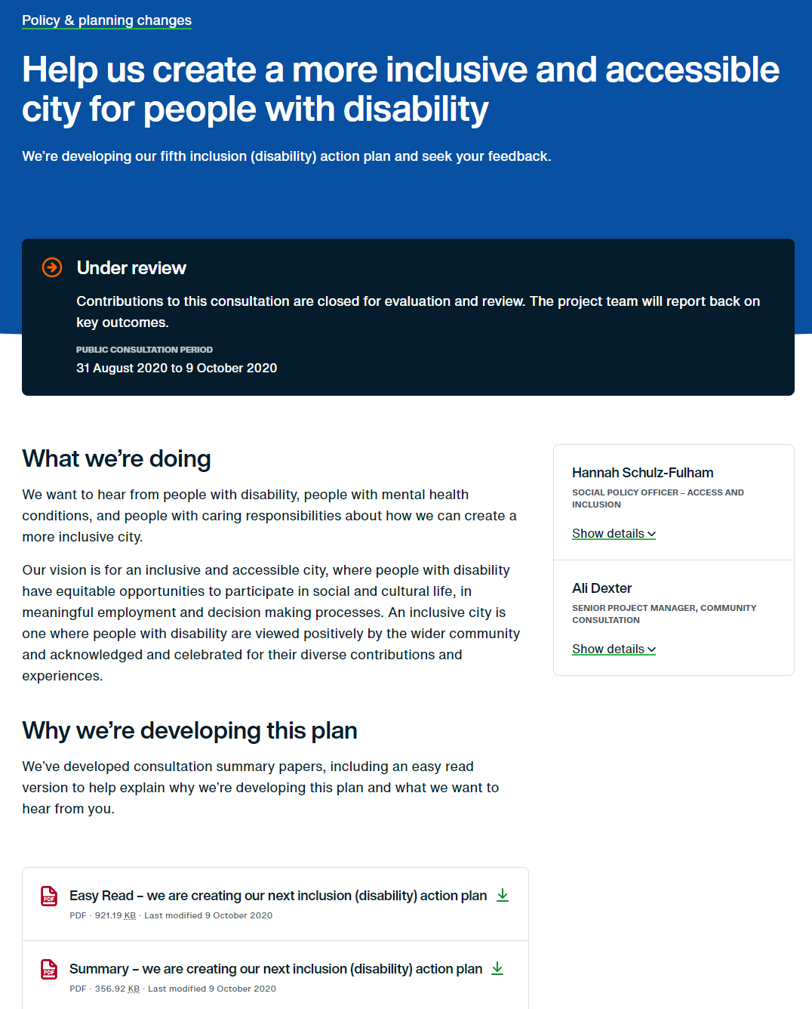
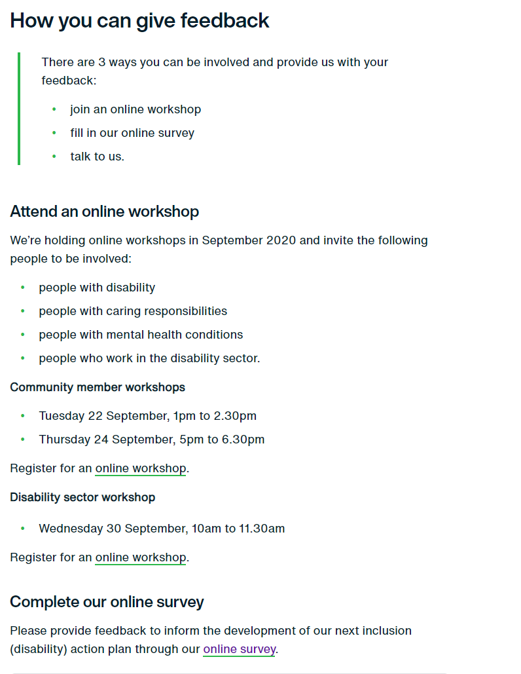

Appendix B: Digital marketing
    - Sydney Your Say e-News

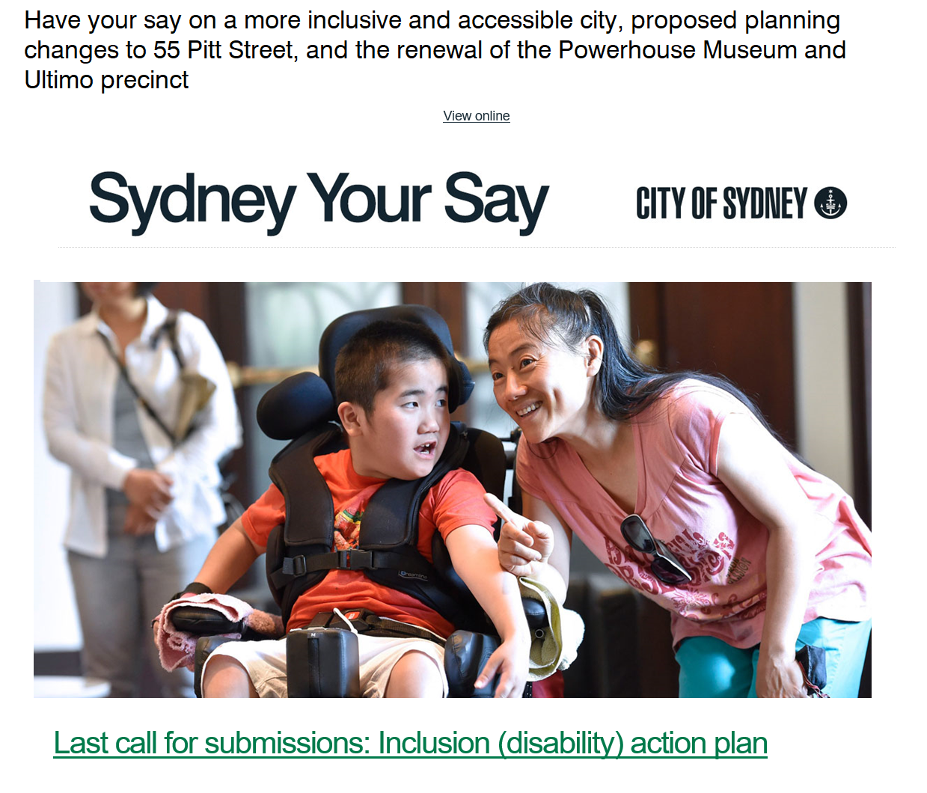

Sydney City News story:
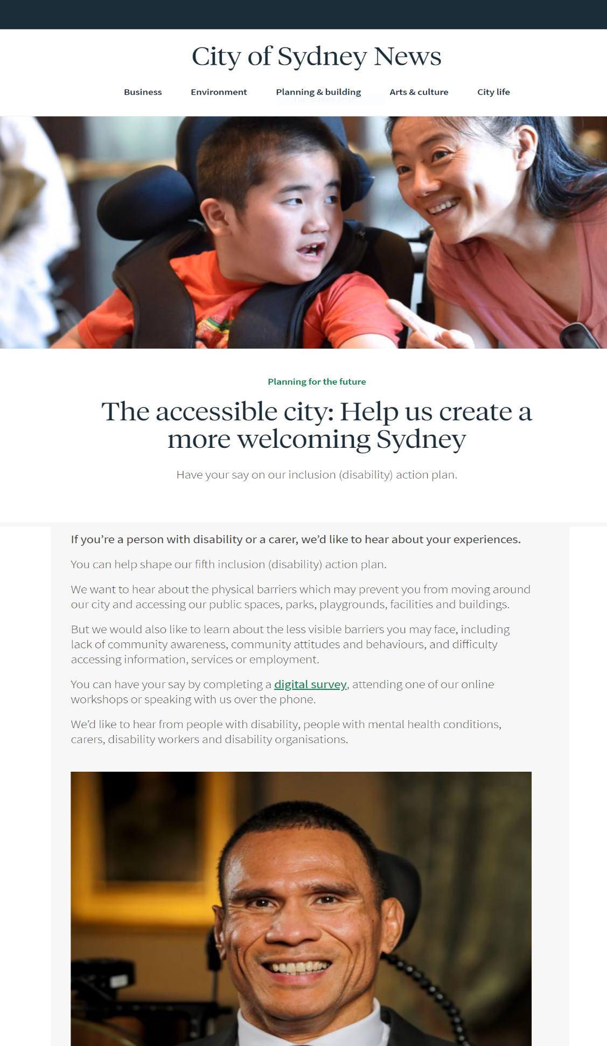

Key stakeholder notification
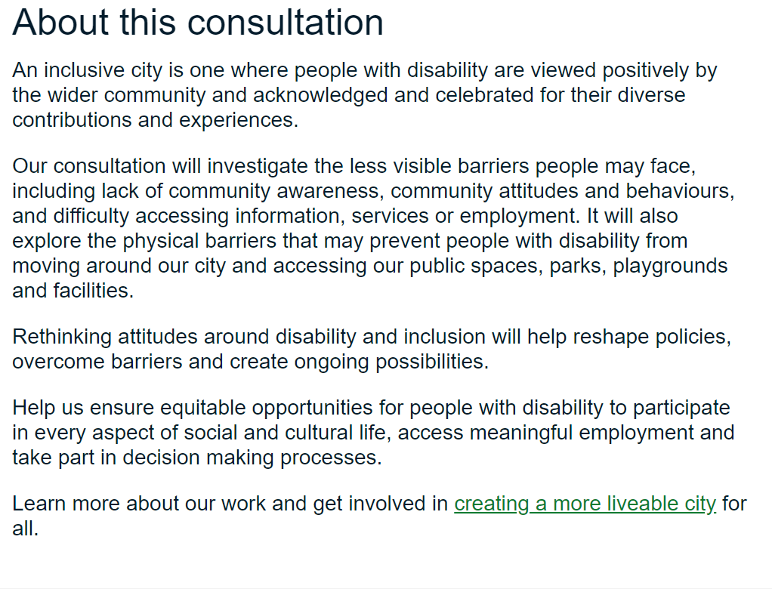
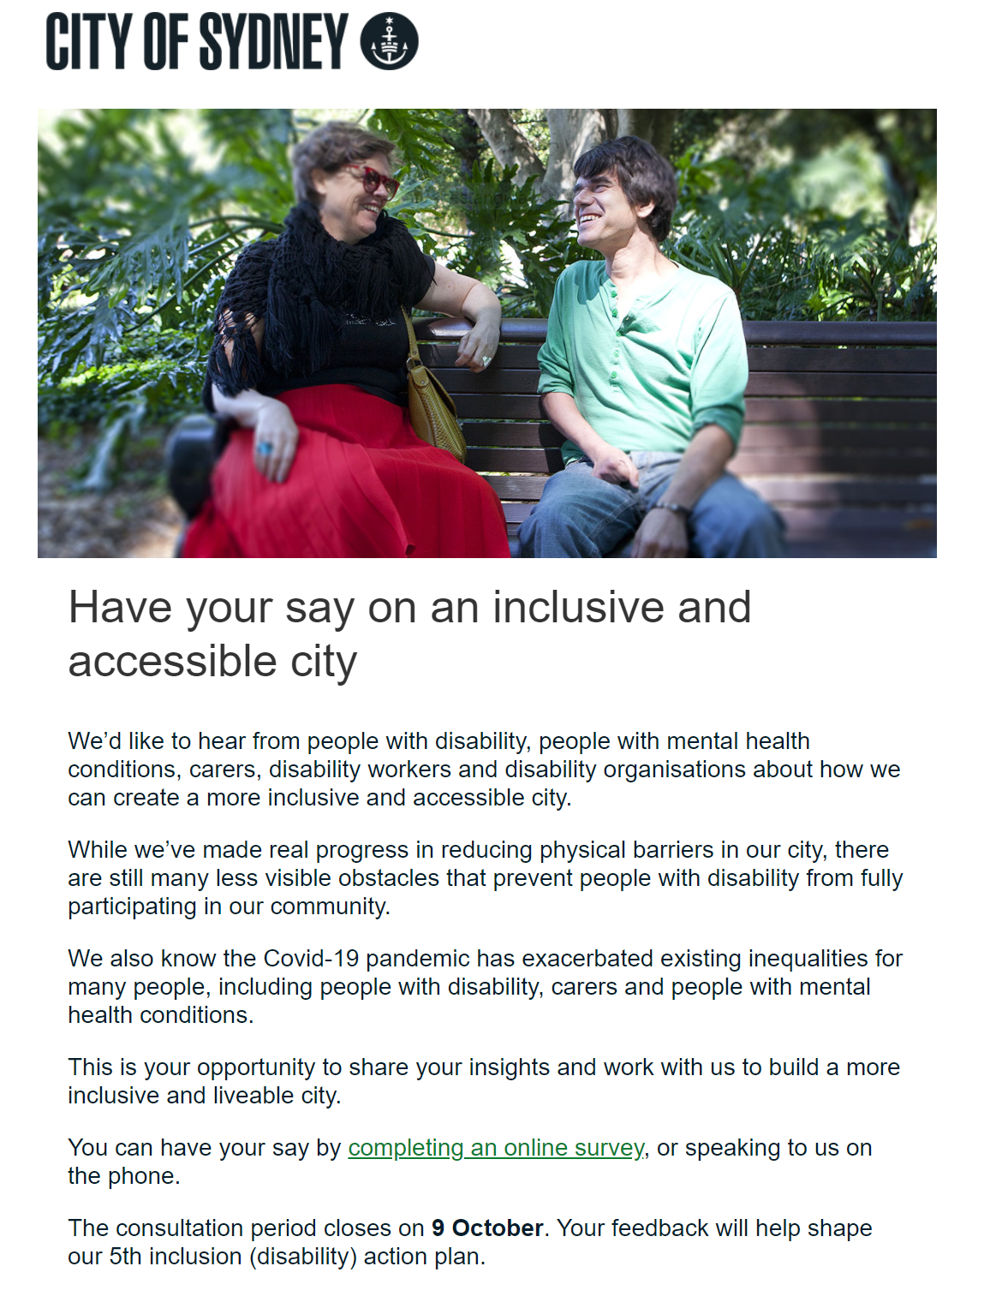
    - Facebook Advertising
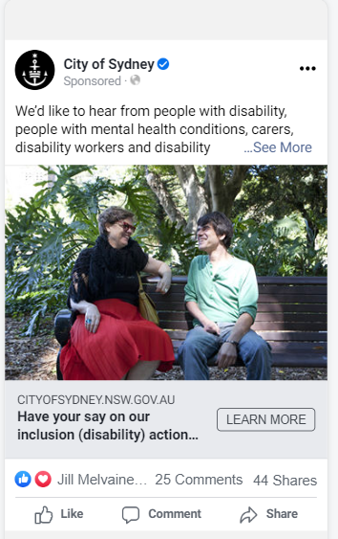
    - LinkedIn Advertising
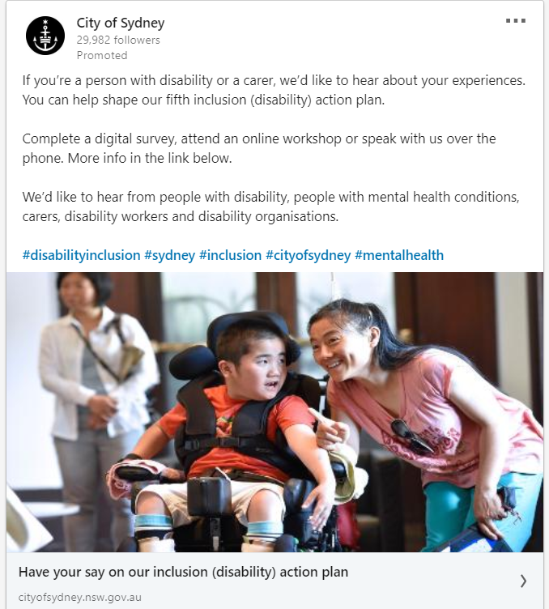

Media release
