Inclusive and accessible event guidelines
Guidelines  August 2023 | The City of Sydney acknowledges the Gadigal of the Eora Nation as the Traditional Custodians of our local area.

Contents
Produce your event for everyone 3
1. Accessible venues and spaces 9
2. Opportunities for inclusive participation and experiences 19
3. Accessible materials and information 29
4. Employee attitudes and awareness 35
5. Online events 38
Checklists 41
Glossary 60
References 63

Produce your event for everyone
These guidelines provide event organisers with minimum requirements and best practice approaches to make events more inclusive and accessible for people with disability and people with access needs.
If the event is a small community event or a major event across multiple days and sites, these guidelines outline key access and inclusion considerations. These should be referred to and worked towards when planning and producing events in the City of Sydney local area.
Inclusive and accessible events provide equitable opportunities for people who live, work and visit the City of Sydney local area to enjoy and participate in the diverse social and cultural events on offer.

Good access is good for business
Accessible businesses receive up to 25% more business, and the added benefits of inclusion provide a greater diversity of customers. It’s been shown that for every $1 businesses spend on access, there is a $13 return on investment. Improving access can also lead to up to 4 times the increase in use of facilities.
In 2021 people with disability spent $13.5 billion a year on Australian tourism accounting for 17% of total tourism expenditure. Making your business more accessible to visitors can open further opportunities to reach:
- older people
- people with temporary injuries or limited mobility
- parents with prams
- multi-generational groups.
Poor customer experiences by people with disability are common. People reported less favourable treatment than customers without a disability, and one in 3 people with disability reported their customer needs were often unmet.
Research found that almost one-third of people with disability over 15 years, avoided situations because of their disability. Moreover, in the past year one in 6 Australians with disability aged 15 to 64 years experienced disability discrimination.
With more than 4.4 million Australians experiencing disability (one in 6 Australians), businesses that improve access and promote customer diversity, and make it easier to buy products and services have twice as much selling power.
While there is an expectation for businesses to be inclusive, accessible and socially responsible, it’s also profitable and makes good business sense.
Disability is a part of the human experience. That is, if a person doesn’t have a disability now, chances are that at some point in their lives they will experience some form of disability, a lived experience of a mental health condition or be a carer.

Legislative and policy context
These guidelines are informed by and meet the requirements under the Disability Discrimination Act 1992 and the objectives of the City of Sydney’s social sustainability policy and action plan and the inclusion (disability) action plan.
The Disability Discrimination Act 1992 makes it illegal to discriminate against a person because of disability when providing goods, services or facilities, or access to public premises. This includes venues where events are held and the activities, performances and services available.
People who plan events, including meetings, festivals, conferences, lectures and fundraisers, need to take all reasonable steps to ensure the event is accessible for people with disability to attend and fully participate.

Where these guidelines apply
These guidelines apply to:
- all City of Sydney produced events
- events and festivals produced by grant recipients in line with our grants and sponsorship policy and guidelines.
These guidelines will also be provided to all event organisers who seek outdoor permits for events and festivals in the City of Sydney area.

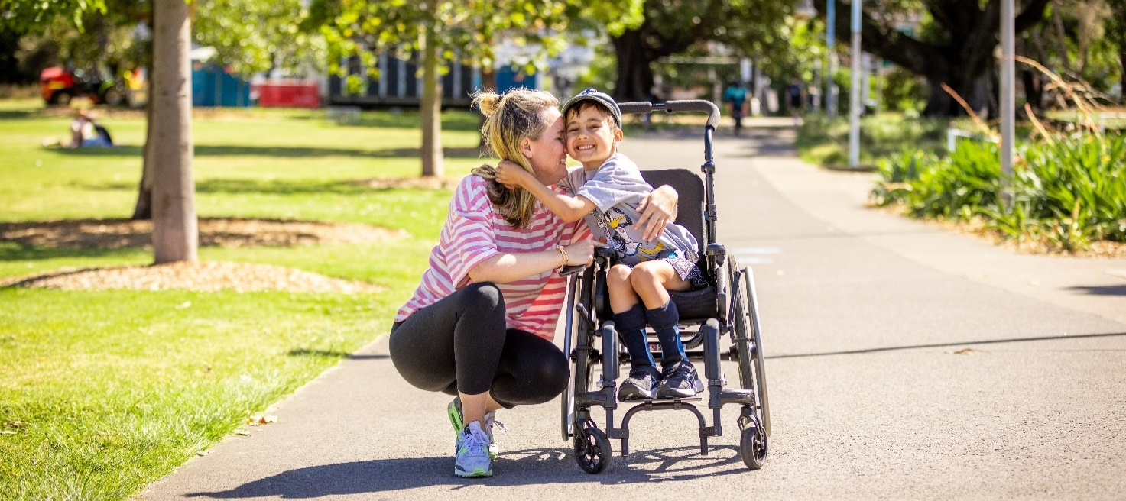
Photo: Mother hugging her child using a wheelchair at the adaptive tennis festival at Prince Alfred Park Tennis Courts 2022. Photographer: Katherine Griffiths

Exclusion Segregation Integration Inclusion

Figure 1: Pictures illustrating what is meant by exclusion, segregation, integration and inclusion.

People with disability
One in 6 people in Australia have a disability. Disability may be acquired at birth or early in life or may be the result of accident, illness or injury throughout life. Disability becomes more likely as we age, with more than half of people aged over 65 living with disability.
When planning inclusive events it is important to understand the different barriers faced by people with disability. These include:
- Physical barriers – lack of access to venues where event activities are held.
- Communication barriers – lack of information and communication in accessible formats.
- Attitudinal barriers – lack of disability awareness, including use of respectful language and assumptions that people with disability can’t participate in certain activities or have unique interests and perspectives.
- Socioeconomic barriers – the cost of events can make them less inclusive for everyone.
- Technological barriers – lack of ability to access and participate in online events due to lack of knowledge about technology used.
Understanding the different types of disability and each person’s needs will help you design, develop and produce inclusive events. Different people face different barriers, depending on their experience of disability. The experience of disability and the barriers faced by individuals may also vary day to day.
For example, people with:
- Physical disability – may face physical barriers in accessing an event venue.
- Cognitive disability – such as developmental delay, intellectual disability and acquired brain injury – may face communication barriers and barriers in accessing information about events.
- A lived experience of mental health – may face attitudinal barriers, for example, assumptions they can’t participate in activities or events or become easily overwhelmed by noisy or crowded environments.
- Sensory disability – such as a person who is d/Deaf or hard of hearing, blind or has low vision, has autism spectrum disorder or sensory processing disorder – may face communication barriers in accessing information or may require support to attend an activity or event.
It is the responsibility of event organisers to provide everyone with equitable opportunities for inclusive participation. It is the law, and it is best practice to plan and produce events that are accessible and inclusive of everyone.
Each person is different. What works for one person may not work for another, even if both people have the same disability. While it is important to plan inclusive events, as far as possible, being flexible, respectful and asking people if and how you can help can go a long way.

Smaller events with limited budget or scope can still work towards producing accessible and inclusive events. Whether it is having access information available on a website, choosing a wheelchair accessible venue to host an event, providing for inclusive participation through providing communications in alternative formats, such as, captions or Auslan, or building knowledge and awareness of disability through training of employees. These guidelines will show you what is possible and give ideas to work towards becoming more accessible and inclusive of people with disability.

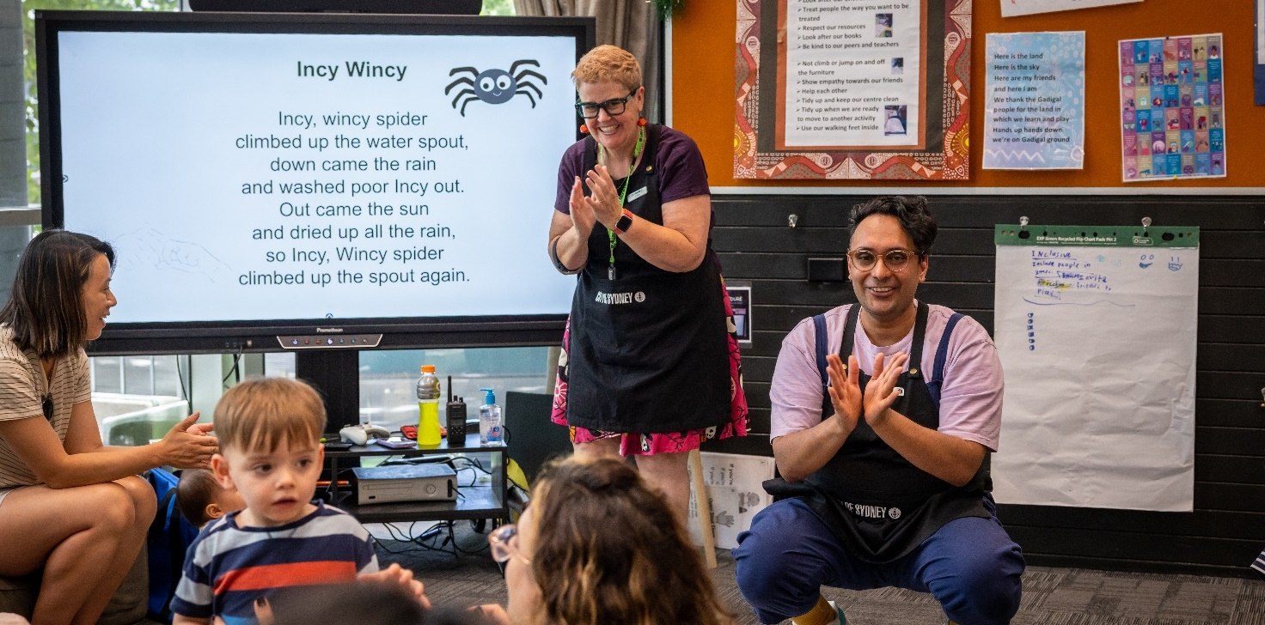

Photo: A group of people in a room enjoying Ultimo Community Centre’s Open Day 2022. Photographer: Katherine Griffiths

Principles of event access
Accessible venues and spaces | Opportunities for inclusive participation  Opportunities for inclusive participation and experiences:Opp | Employee attitudes and awareness  Accessible materials and information  WELCOME
- The event is in an accessible venue or space.
- Appropriate infrastructure is used to maximise access within and around the venue or space.
- People with disability can experience event activities in a shared and inclusive manner.
- Inclusive communication such as presentations, announcements and speeches are provided in accessible formats.
- Event materials, including promotions, documents, presentations, plans, designs and maps – both print and online – are accessible and/or available in alternative formats.
- The access features of the venue or activity are part of promotional materials to allow people with disability to make an informed decision about participating before the event.
- Online event platforms and software are accessible and inclusive.
- Event employees are welcoming and confident in communicating respectfully with people with disability and have sound disability awareness.
The following 4 principles provide a framework for planning inclusive and accessible events.

Types of events and access requirements
If you take time to plan and consider these guidelines, there are simple and easy ways to make your event inclusive and accessible.
Access and inclusion requirements should be considered early in event planning and built in throughout process.
All event organisers should aim for best practice accessibility. While smaller events may have limited resources these guidelines can help meet the following minimum requirements.
Minimum requirements
Venue (both indoor and outdoor) | - The venue is wheelchair accessible with step free entry and a continuous accessible path of travel to all event areas.
 | - There are accessible toilets available at the event.
Opportunities for inclusive participation | - Auslan interpreters, live captioning, audio description is provided on request (when the type of event, size and location allows).
Accessible materials and information | - Where possible, ensure event websites and digital documents comply with Web Content Accessibility Guidelines WCAG 2.2.
 | - Avoid using PDF invitations in digital communications.
 | - Event promotions should provide detail of the access features available at the event where provided, such as hearing loops and interpreters.
 | - Provide contact details of event organiser, including phone number, email and website for people who need more information from someone who can answer questions.
 | - Ask guests in invitations and promotional materials about individual accessibility support needs they may have.
 | - Be prepared to provide accessible formats if requested, including Microsoft Word, large print, audio, Braille, Easy Read.
Employee attitudes and behaviours | - All employees preparing or participating in an event, including contractors such as security and catering, and volunteers, should be briefed by the event organiser about key access features of the event space.  - All employees are provided with a briefing on communicating with people with disability and are aware of inclusive language.
Online events | - Ensure video conferencing or webinar software is accessible.  - Provide a phone number or dial in method.  - Provide accessibility requirements requested by participants and event materials in accessible formats.
- Accessible venues and spaces
Making sure the venue, if it is indoors or outdoors, is accessible means that everyone, including people with limited mobility, families with young children and older people can travel in and around the venue.

Minimum requirements

Accessible entrance and the continuous accessible path of travel
An accessible entrance (step free) and a continuous accessible path of travel throughout your event will support independent and dignified access for people with disability. All events should provide as far as possible an accessible entrance that is:
- step free, flat and has a clear opening wider than 1000mm, or
- accessible by ramp that is no steeper than one in 14 incline (See Australian Standards 1428.1), or
- accessible by lift.
As far as possible, a continuous accessible path of travel should be available. A continuous accessible path of travel is a route within a building, venue or space that:
- is free of steps, turnstiles and obstructions such as signs and stalls, furniture or temporary infrastructure, such as power cabling or art installations
- provides a minimum 1000mm wide clearance (indoors) and as far as possible 1200mm in width (outdoors) – for high volumes of people 1800mm passing spaces should be provided every 20m (outdoors)
- has at least 2000mm height clearance under any signs, trees or other infrastructure above the path of travel
- includes temporary ramps and cable trays for outdoor events as required
- avoids surfaces such as grass and rough gravel that can create trip hazards for people who are blind or have low vision, older people, people using wheelchairs or who have spinal sensitivity.

Accessible toilets
All events should provide accessible toilets. Either use existing accessible toilets in the facility, venue or park, or hire portable accessible toilets.
There are many types of portable accessible toilets available, but not all comply with current standards. Make sure portable toilets comply with AS1428.1 and are placed in an easily accessible location with appropriate signs.
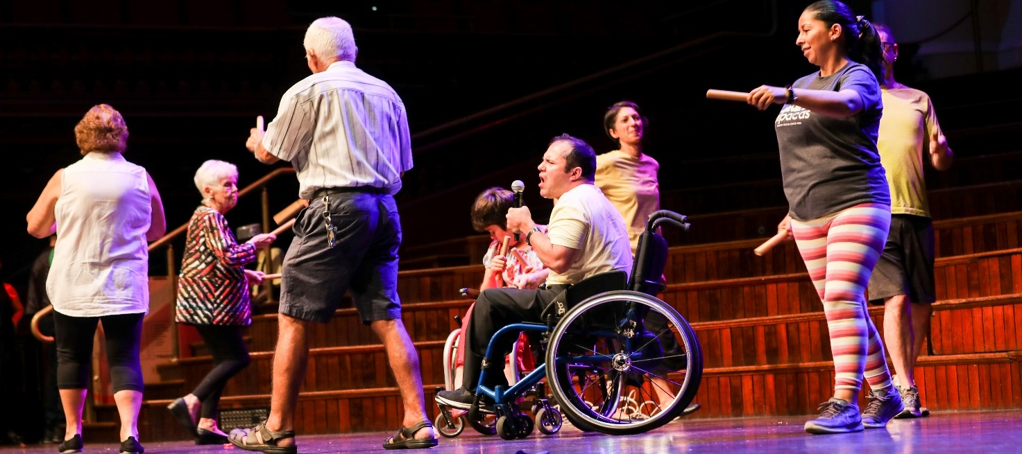Photo: Cliff Noble Community Centre members performing at Communities Got Talent at Sydney Town Hall in 2020. Photographer: Katherine Griffiths ____________________________________________________________________________________________________________
As a minimum wheelchair accessible toilets must:
- have a minimum ratio of one wheelchair accessible toilet for every 10 standard toilets
- not be locked or used as a storage area
- comply with AS1428.1 – not have foot pump operated sinks and provide a minimum circulation space 1900mm wide and 2300mm length.
Make sure the portable accessible toilets:
- are located next to a continuous accessible path of travel
- include a landing at the top of the ramp for wheelchairs to stabilise and turn appropriately
- are located on firm, level ground or accessible by ramp no steeper than one in 14 inclines (when not located on level ground)
- provide a mix of toilets with left and right-hand transfer configurations, where more than one portable accessible toilet is provided.

Accessible adult change facility
Accessible toilets do not meet the needs of some people with disability that require access to accessible adult change facilities to enable participation at events and festivals.
Access to accessible adult change facilities with a hoist and change table can make a significant difference to the lives of people with high support needs allowing them to participate in events.
Portable accessible adult change facilities are available for hire for events. Providing this facility can provide people with disability increased independence, dignity and freedom.

Temporary structures
All outdoor events should provide people with equitable and dignified access into any temporary structures.
These structures must be accessible to people using wheelchairs by providing an access ramp.
In particular:
- the ramp should comply with Australian Standards 1428.1
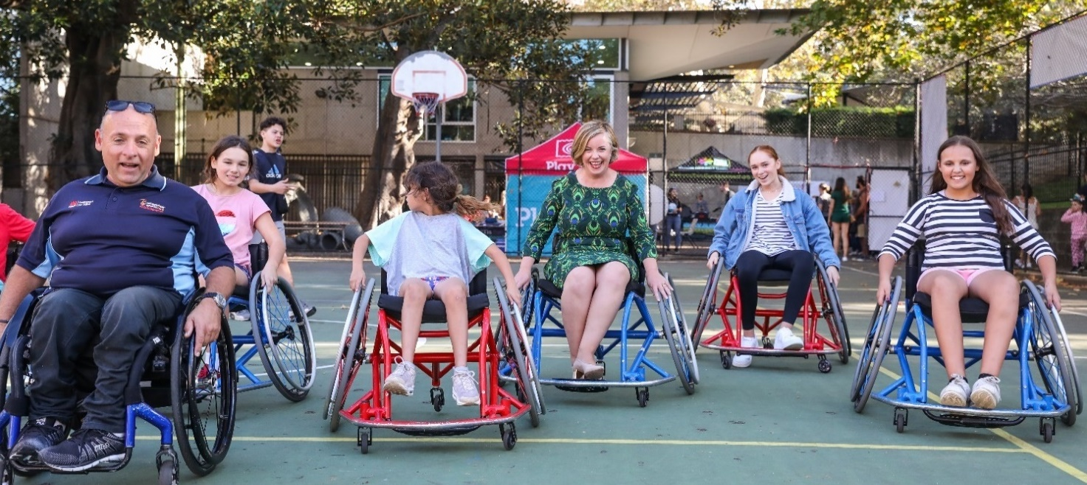
Photo: Yurong Parkway Basketball Court for Youth Week celebrations in 2019 / Photographer: Kathrine Griffiths
____________________________________________________________________________________________________________
- as far as possible, the ramped entry to the temporary structure will be the main entrance
- where it is not possible to provide a ramp, look at providing a platform lift or reconsider if the structure is necessary at all.
Where the accessible entrance is not the main entrance:
- it should be no more than 50m away from the main entrance
- its location should be clearly signposted at the main entrance
- it will be clearly signposted as an accessible entrance.

Event wayfinding and signs
Wayfinding and signs help people find their way to and around an event venue or space.
Wayfinding signs and maps help people understand the event environment and be confident about attending the event and participating in the activities on offer.
Where wayfinding signs are provided at events, they must:
- provide good colour contrast between one surface or component and another surface or component – use Vision Australia’s Colour Contrast Analyser to check foreground and background colour combinations to determine if they provide good colour visibility
- use large sans-serif font
- use minimum 18-point font
- avoid using all capital letters – only capitalise the first letter
- use directional arrows
- be well lit and easily visible
- be located at entrances and decision points
- provide direction to key event areas such as performance and food service spaces
- provide directions to accessible infrastructure, such as accessible toilets and accessible seating and viewing areas
- have signs at destination points to confirm location
- provide directional signs at a height that can be seen from a distance, taking into consideration crowd density and people who use wheelchairs
- not obstruct the continuous accessible path of travel or kerb ramps
- have a minimum of 2000mm height clearance under any sign that extends over the path of travel
- be located near to a continuous accessible path of travel or service area and at a height to enable use by people with low vision or wheelchair users – see Wayfinding Standard (AS 1428.4.2) for details.
A large part of wayfinding and information services during an event comes from employees and volunteers.
- make sure employees know the layout of events and accessible paths of travel
- consider disability awareness training to ensure confidence when interacting with people with disability.

Wayfinding maps
Good wayfinding at a large event helps people find their way around independently. Major events and festivals should have wayfinding systems that include venue maps at entrances and exits, as well as in promotional materials and on websites.
The maps should indicate the continuous accessible path of travel, and key destination points including:
- entrances and exits
- toilets, including accessible toilets
- information points and first aid
- food and drink service areas
- ticketing booths
- stalls and performance areas
- accessible seating and viewing areas.

For outdoor events
When planning and hosting outdoor events, make sure the layout of the event makes the best use of existing footpaths and kerb ramps by placing key accessible infrastructure alongside. For example, stalls, accessible toilets, drop-off areas, stages and emergency exits.
Make sure key event infrastructure such as stalls, signs and traffic control barriers do not block existing kerb ramps.
Where there is no permanent footpath forming a continuous accessible path of travel, use temporary access matting complaint with AS1428.1 so there is a flat and clear pathway to key event infrastructure:
- the pathway should be continuous, with no breaks or gaps
- where there are stairs, identify an alternative accessible path of travel, or provide a ramp or lift
- make sure trucks setting up during bump in and out do not block the continuous accessible path of travel
- where temporary ramps, stairs, cable trays and matting must be used, they must comply with AS1428.1.

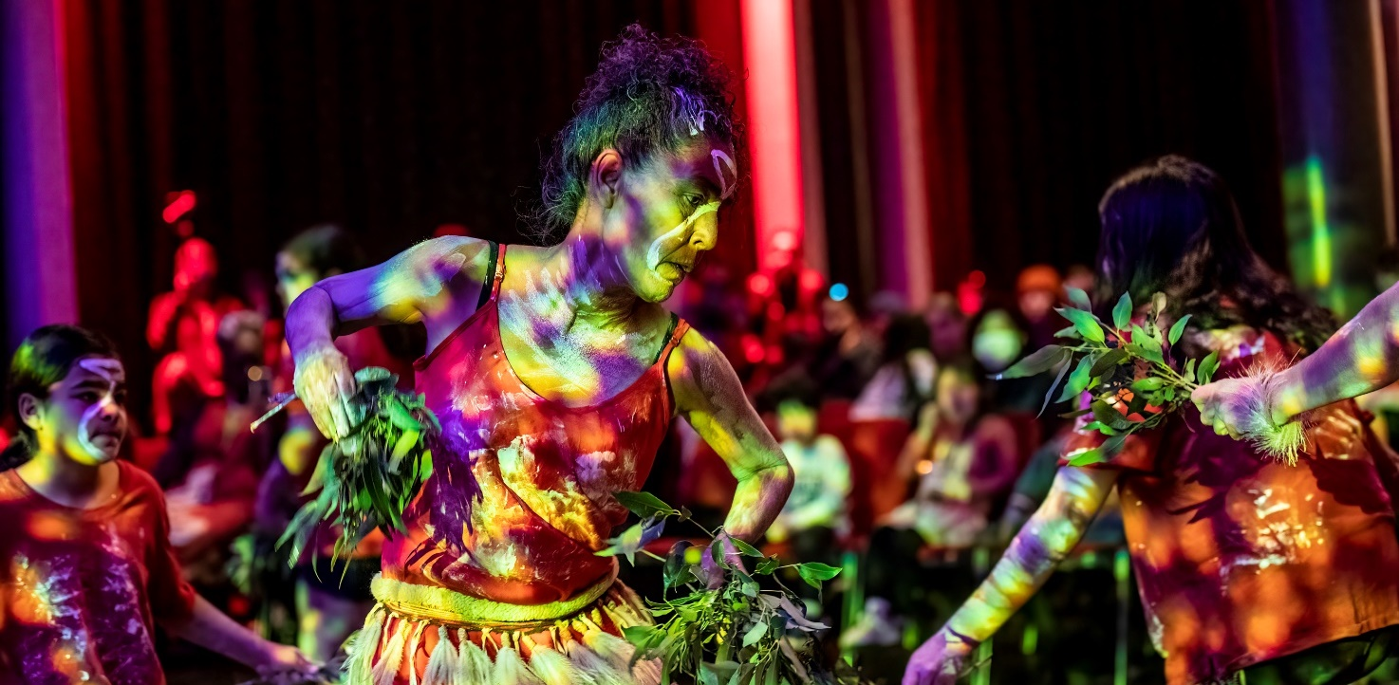
Photo: Aboriginal dancers performing for NAIDOC Week 2022 at Sydney Town Hall. Photographer: Joseph Mayers

Other things to remember
- Inappropriately placed event infrastructure can create barriers to access. Make sure signs, furniture and stalls are well spaced to allow people to move around them, including people using wheelchairs and other mobility aids.
- Uneven surfaces such as grass and loose gravel/pebbles can be difficult to cross, particularly if someone is using a wheelchair, mobility aid and/or is blind or has low vision.
- Choosing a facility or venue that has a hearing loop available can provide access for people who are d/Deaf or hard of hearing.
- Using a microphone at an event, even at small events, can assist people who are d/Deaf or hard of hearing.
- Providing power points for people who use mobility scooters to recharge their scooter will help them stay longer. Make sure the power points are between 230mm and 1350mm high for people using scooters to reach them and there are appropriate signs. Don’t assume that everyone will be able to reach a power point without assistance.
- Consider nearby access to a park or facilities where assistance animals can take breaks.
- Where you are providing temporary seating, make sure at least 25% has back and arm rests. This helps older people to get up from a seated position.
- When outdoors, include designated rest areas and consider shade to give people a break from the sun.

Nidhi Shekran

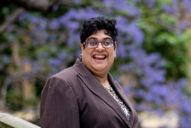
Photo of Nidhi wearing a brown suit smiling at the camera
Handy tip: Remember to make events accessible and inclusive through the entire event experience – from the very beginning in getting there, to allowing for inclusive participation by people with disability, to completing the journey and returning safely home again. To do this, make sure access and inclusion is at the forefront from the very beginning of the event planning, and not as an afterthought.

As a person with low vision and cerebral palsy, I have difficulty with depth perception and balance and can only see at a 45-degree angle. I need to constantly scan across my visual field to be able to take in my environment to know where I am and where I’m going. This can make wayfinding difficult, particularly at busy events with many people and noise.
Attending events can be extremely stressful for me, so I need to pre-plan to make sure I know where I am going and how I’m going to get there ahead of time. I will check an event website to make sure its accessible and inclusive, ensure that I have a map, and a phone number to call for help should I need it. Still, getting lost has happened a number of times to me in the city, and I can get very distressed trying to find help and to work out how to get where I need to go. Well-meaning people can try and guide me but then I may become more disorientated and lost.
If I know an event is accessible and inclusive, and I know there is an accessible venue, information available in alternate formats, and trained and supportive employees – I feel safe in attending.

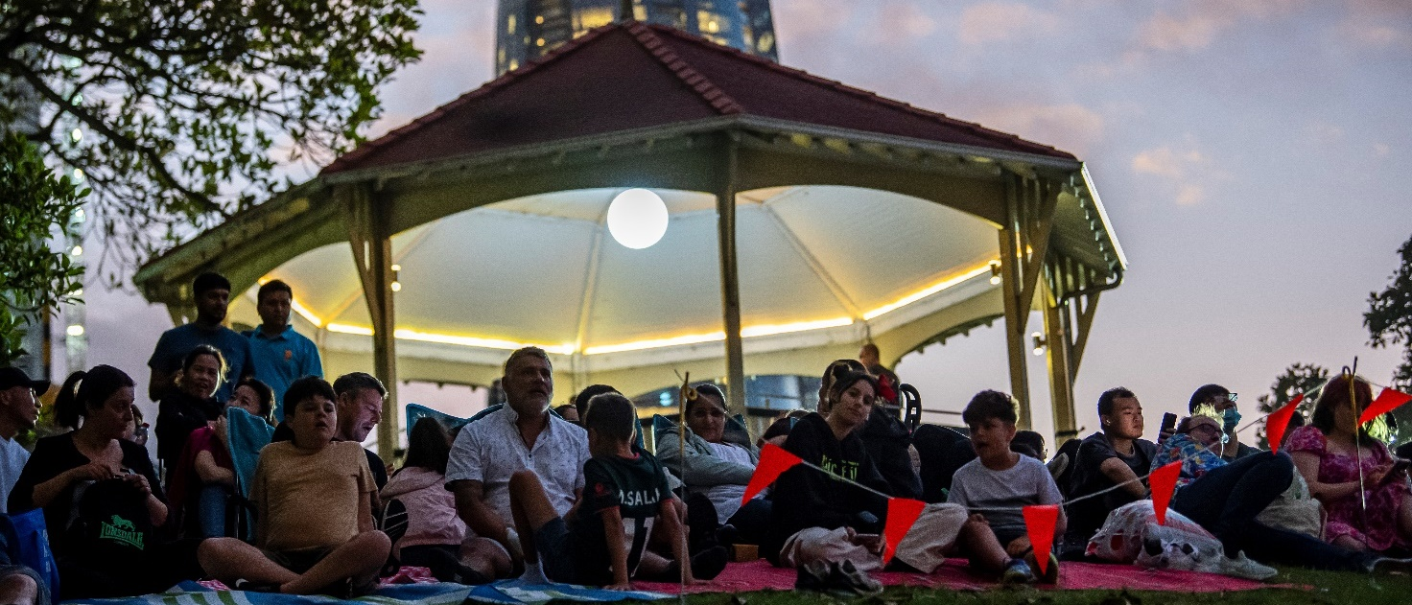
Photo: Families sit on Observatory Hill on New Year’s Eve 2022 / City of Sydney, Photographer: Justin Sansom

Case study: Sydney New Year’s Eve
The City of Sydney chairs an accessibility working group for Sydney New Year’s Eve. It includes the Department of Premier and Cabinet, Department of Regional, Harbour Trust, National Parks and Wildlife Service, North Sydney Council, Placemaking NSW, Royal Botanic Garden, Sydney Opera House, Taxi Council and Transport for NSW. The group meets every 4 to 6 weeks in the lead up to New Year’s Eve to discuss all aspects of accessibility. Site visits are undertaken pre-before the event to assist with appropriate planning and improved customer experience for vantage points.
The aim is to provide the best possible journey and event experience for audiences with access needs. Accessible viewing areas provided by the City of Sydney at Observatory Hill and Pirrama Park aim to cater to a diverse range of people with accessibility inclusions with and helpful employees available.
The City of Sydney provides a designated accessible viewing areas for a combined 130 patrons, including support persons. A golf cart service and Changing Places facility is available at Observatory Hill Park, and an accessible change room and drop off drop-off zone at Pirrama Park.

All City of Sydney designated accessible viewing areas have seating available as well as an employee to assist patrons where required. There are 9 designated accessible viewing areas listed on the Sydney New Year’s Eve website.

The website also provides translated versions of the event guide available in 6 different languages, and an audio guide. Large print, and Easy Read event guides are also available on the website and at information booths. An accessibility officer is employed from October through to January.
Handy tip: Communication and consultation is the key to producing a good accessible and inclusive event. It is important to seek advice and feedback and provide information to assist with the whole of the event journey.
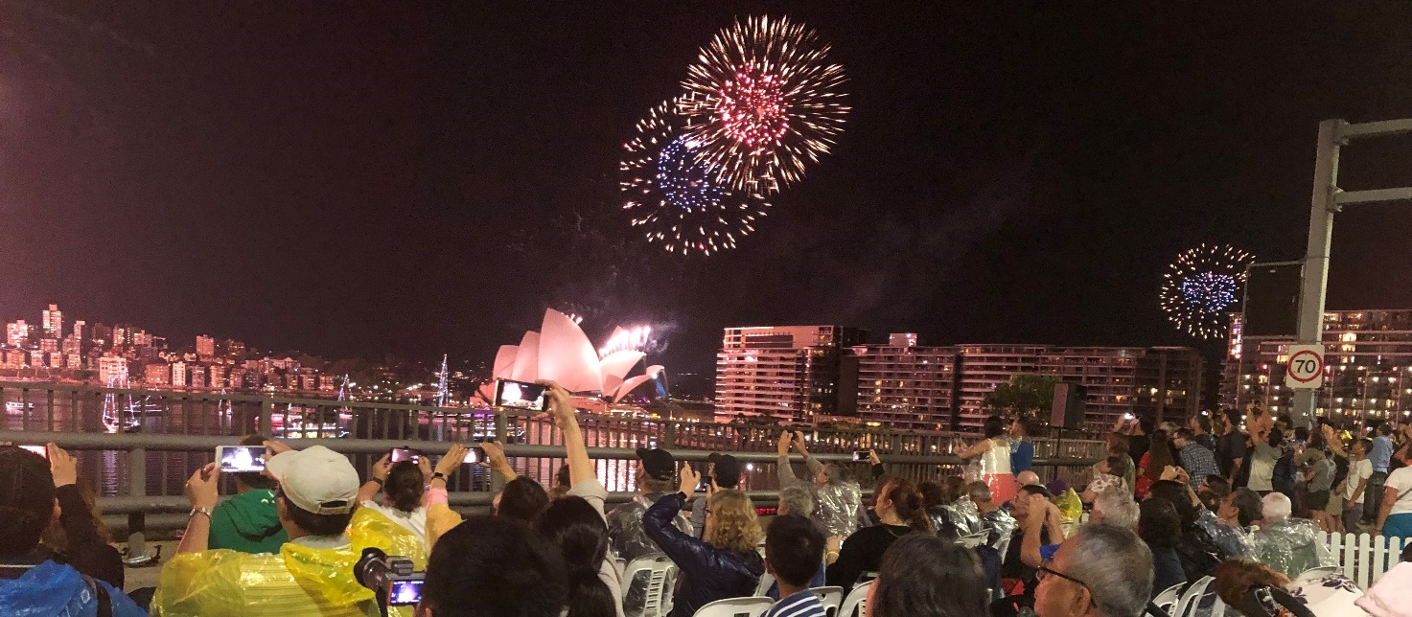
Photo: People watching the New Year’s Eve fireworks from the accessible viewing platform at Cahill Expressway in 2022. Photographer: Karen Wade

Best practice considerations

Emergency exits
Being able to evacuate in an emergency is just as important as being able to get into an event. Event organisers should consider the following as part of event planning in case of an emergency:
- use accessible communication strategies such as visual alerts for people who are d/Deaf or hard of hearing and calmly explain to people with intellectual disability what to do
- identify designated employees or appropriate emergency services to provide added assistance for people with disability if required
- identify multiple accessible evacuation routes to emergency assembly points and make sure employees are aware of them.

Public transport and accessible alternatives
Planning an inclusive event means considering how people can get there. Key considerations include:
- accessible public transport – identify and communicate the different types of accessible transport options available to and from your event
- identify a continuous accessible path of travel from transport to the entry (step free), avoid steep gradients and where possible regular rest points every 50 to 75m.
While active transport options such as walking and cycling are the City of Sydney’s recommended transport mode we know that for many people with disability this is not an option.
Accessible parking, drop-off and pick-up points and buggy services can make events accessible to people with limited mobility.
Where possible provide:
- a minimum 1% of onsite parking spaces to be accessible
- information about the closest on-street mobility parking spaces and commercial parking stations with accessible parking when onsite accessible parking is not possible
- a traffic management plan providing designated drop-off and pick-up areas for people with limited mobility (subject to approval of the local pedestrian, cycling and traffic calming committee)
- for smaller events, identify safe and accessible drop-off and pick-up points (no stopping zones) near the venue – these can be used for up to 5 minutes for drop-off or pick-up as long as driver remains within 3m of the vehicle
- a drop-off and pick-up area that has a kerb ramp available to allow a person using a wheelchair or other mobility aid to get from the road onto the path to the entrance
- consider providing alternative options for people who are not able to walk to the event from public transport locations, such as community transport or buggy services for people with restricted mobility.
The City of Sydney’s accessibility map identifies the location of public transport stations, on-street mobility parking spaces, public toilets, seats, lifts, stairs and more.

Disability inclusion action plans
When planning an event, you are legally required to provide access and inclusion for people with disability.
Major events and festivals, or organisations that produce frequent events should consider developing a disability inclusion action plan. It should outline a vision for disability inclusion that will help to achieve equal participation and promote disability rights, and states clear actions that will be undertaken to help achieve those outcomes.
Disability inclusion action plans map out who will be responsible for each action, when it will be achieved by, and a measure for the outcome to understand what success looks like.
It is best practice to involve people with disability in developing your disability inclusion action plan, by gathering feedback and understanding what people with disability want and need and how best to achieve it.
Smaller events should consider developing an access and inclusion statement of commitment during the event planning stage and make it publicly available.

Lived experience feedback and co-design
Many major events and festivals have organising panels that include diverse people with disability to help embed access and inclusion at every point of the customer experience.
If a panel is beyond the ability for your event, it is best practice to consult with people with disability about key areas of event planning to gain greater understanding and provide better access and inclusion. You may also wish to get feedback from people with disability that attend your events, to allow for continuous improvements to be made.
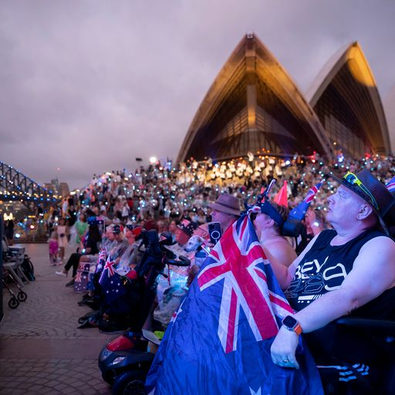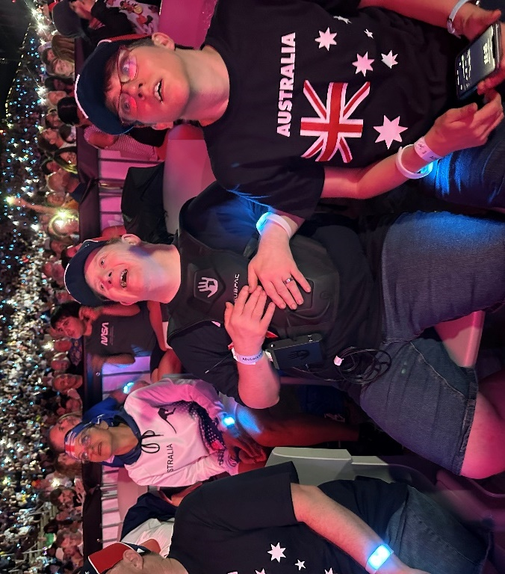
Photo 1: A crowd of people sitting in the accessible viewing area on Australia Day 2023 outside of the Sydney Opera House. Photographer: Karen Wade
Photo 2: A man wearing tactile vest technology to ‘feel’ the music at Australia Day celebrations 2023. Photographer: Karen Wade

Case study: Australia Day Live 2023
Australia Day Live 2023 is a great example of accessibility and inclusion, that the NSW Government is proud to promote as an event that can be enjoyed by all. The event provided an accessible viewing area was built into the general seating configuration, providing an immersive and dignified experience for guests. A quiet room and sensory spaces were provided in partnership with Autism Spectrum Australia.
The NSW Government used innovative technology to trial tactile vests, giving guests from the d/Deaf and DeafBlind community the opportunity to ‘feel’ the beat of the music in real time.
Event patron quote: “Attending this event is like a rite of passage for all teenagers. My son’s disability should not exclude him from attending this event with his peers. I thank the event organisers for making this event accessible so that my son and others can participate as equals”.
A ‘touch-touch’ opportunity was provided before our live event for our guests with a sensory disability to take a tour of our stage and venue to become familiar with the event before it began. A person with lived experience of disability was a main performer for the Australia Day Live harbour finale. Accessible options included transport from key areas in the city centre and a customised event accessibility registration page and website.
Other provisions included Auslan interpreters, areas for assistance dogs, 2 Changing Places amenities, multiple all-gender wheelchair accessible portable toilets, powerchair/scooter recharging areas and inclusion customer service volunteers.
Handy tip: The built environment, along with communications and community attitudes pose the most significant barriers and biases for people with disability. Inclusive events like Australia Day Live are a great way to break down and remove community barriers to achieve equity, dignity and inclusion.
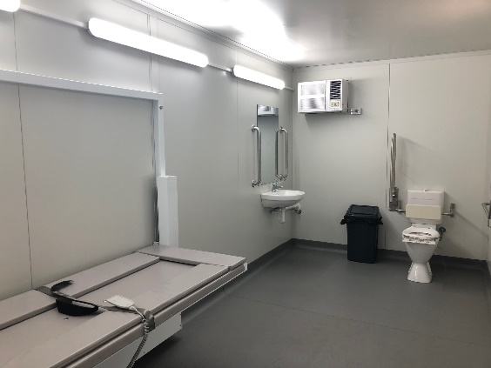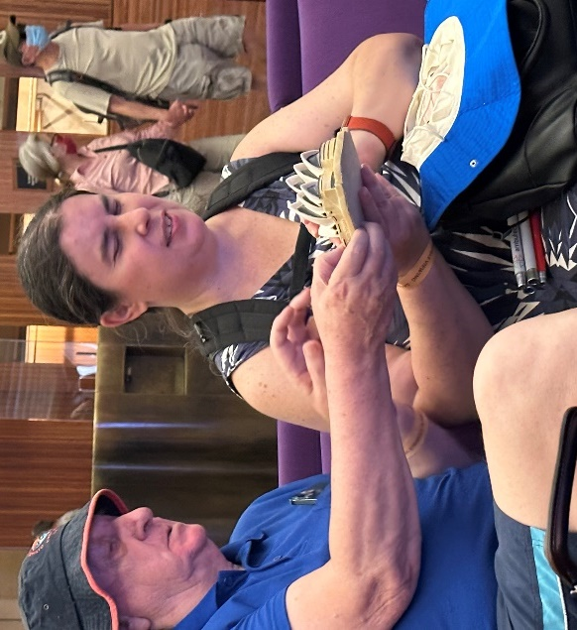
Photo 1: Portable accessible adult change facility with adult change table available at Australia Day Live.
Photo 2: Woman participating in tactile tour with her support person at Australia Day Live 2023. Photographer: Karen Wade

2. Opportunities for inclusive participation and experiences
This is about making sure people with different disabilities can participate and experience all your event has to offer in a dignified and equitable manner.

Accessible seating
When planning your event make sure:
- people who are d/Deaf or hard of hearing can choose seats with clear sightlines to Auslan interpreters and screens with captioning
- people who are blind or have low vision are seated closely to presenters, stages or performance areas to hear better
- rows of seats have enough space between them for people to move in and out easily, or provide spaces at the end of the row for people who use mobility devices, such as walking frames
- some seating includes arm and back rests
- people using wheelchairs are dispersed with non-wheelchair spaces to allow people with disability to sit with friends and family.
Consider this guidance for appropriate grouping and distribution:
Number of fixed seats in a room or space | Number of wheelchair spaces | Grouping and location
Up to 150 | 3 spaces | single space; and 1 group of spaces (mixed)
151 to 800 | 3 of 150 seats | other group
Communicate these requirements to event employees, booking operators and security personnel so they can assist people to specific seating options. They should also be familiar with the different seating options and their locations.

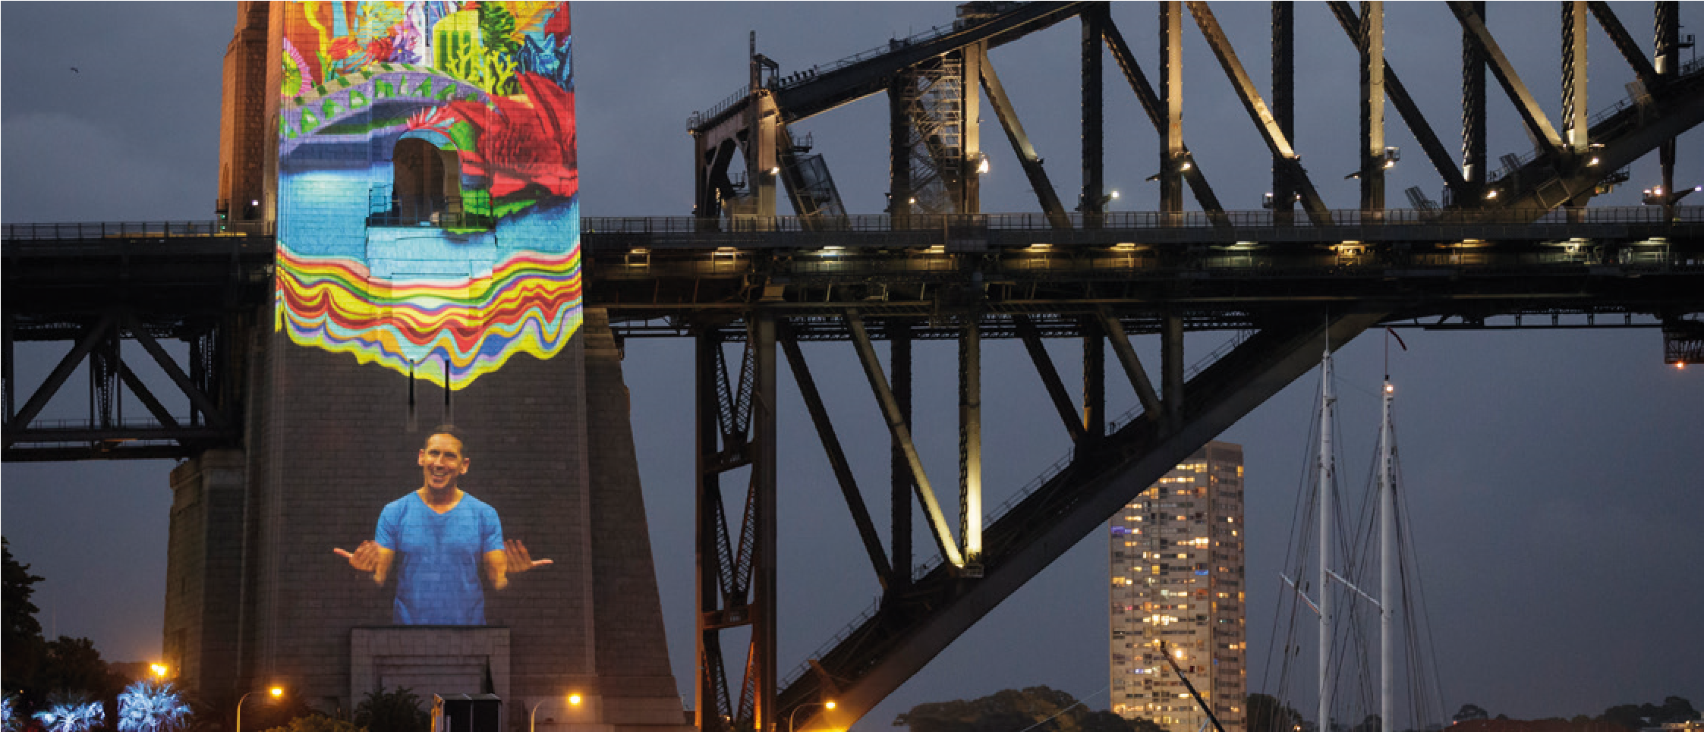
Sydney New Years Eve 2016. Auslan interpreter projected on to Sydney Harbour Bridge Pylon. Photographer: City of Sydney

Accessible viewing areas
Where seating is not allocated, provide ‘no standing areas’ or designated ‘accessible viewing areas’ or platforms.
A no standing area is a location within a venue or at an event that accommodates everyone, particularly people who use wheelchairs or other mobility devices or people who need to sit instead of stand. It has good sightlines to the performance area.
An accessible viewing area is a location within a venue or at an event that is accessible for everyone, including people who use wheelchairs, mobility scooters, walking frames or other mobility devices.
These areas should be:
- located next to a continuous accessible path of travel
- within clear sightlines to the event or screens for viewing alternative communication, such as Auslan interpreters, live captions and audio description
- clearly indicated on the event map
- promoted on the event website and available for booking if possible
- inclusive of friends and family of people with disability
- described as an ‘accessible seating or viewing area’ or ‘no standing area’ – not disabled or wheelchair areas
- as far as possible, providing shelter in the event of rain.

Why is this important?
- Just like anyone else, people with disability have the right to choose their seat and the opportunity to sit with family and friends
- People who use wheelchairs may not be able to view the event due to the lowered seating position and other people standing in front of them
- d/Deaf people or people who are hard of hearing need clear sightlines to see Auslan interpreters, live captioning and to lip read
- Seating that includes back and arm rests is beneficial particularly for older people and people who may have reduced core strength or may need to rest
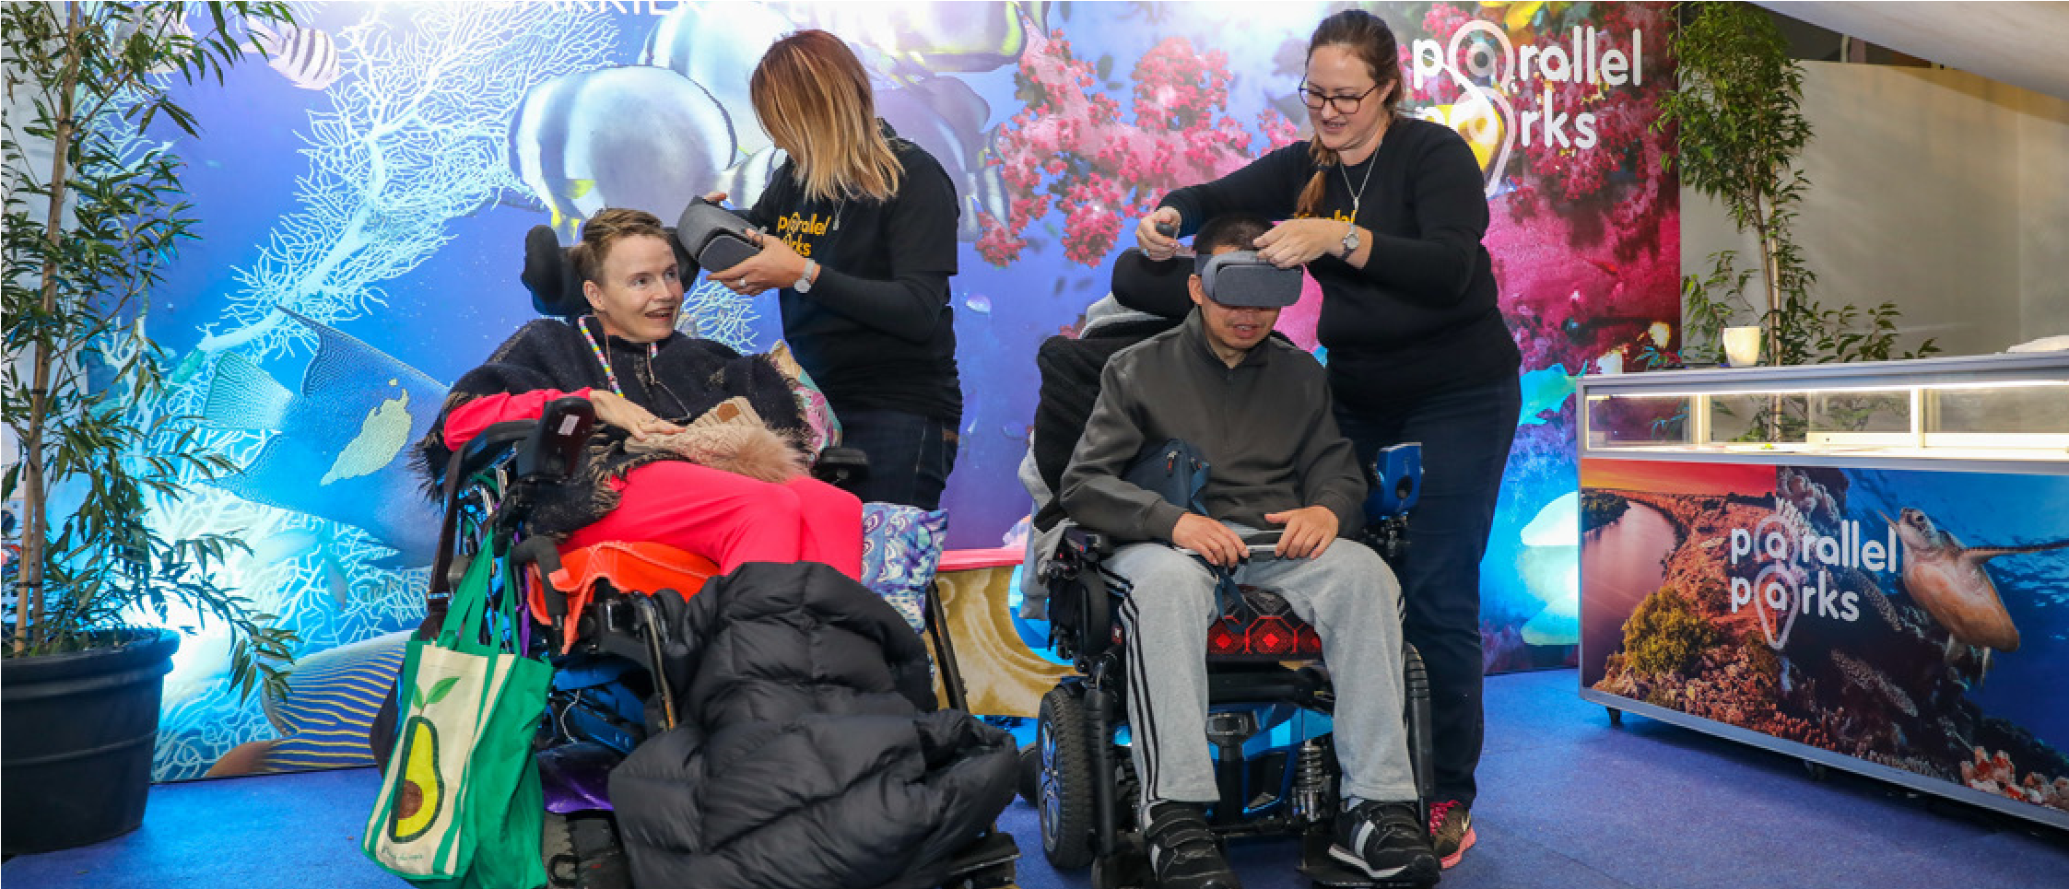
Photo: Parallel Parks. People explore the Great Barrier Reef at Customs House Library using virtual reality headsets. Photographer: Katherine Griffiths

Accessible service areas
Service areas include ticket booths, reception areas, sign-in areas or food and beverage stalls. When planning your event, think about the following to maximise the accessibility of service areas:
- provide accessible counter heights of around 800 to 850mm
- if accessible counter heights can’t be provided, make sure employees are available to assist people with disability to access services located behind the service area
- have a hearing loop available at the service counter, along with signs – portable cross-the-counter hearing loops are available and easy to set up and use
- have large print menus (minimum font 18pt) and menus with pictures available on request
Avoid handwritten menu boards as they can sometimes be difficult to read from a distance. The following font and styles will help make your menu board accessible when viewed from different distances in service areas:
- minimum 18-point size font
- sans serif font
- single spacing between lines
- different font sizes to distinguish between headings.
See Vision Australia’s online and print inclusive design and legibility considerations for further requirements.

Why is this important?
- If a service area’s counter is too high, then it can be difficult for someone in a wheelchair to access and communicate with dignity
- People who are d/Deaf or hard of hearing may find it difficult to hear at a busy customer service counter unless a hearing loop is available
- People who are blind or have low vision, people with intellectual disability and people from culturally and linguistically diverse backgrounds may have difficulty reading signs that are too small or handwritten
- People who have difficulty with accessing information may benefit from simple menus with photos to represent the options available
- A service area that is more accessible and equitable for everyone can also increase business
Remember
If someone requests access supports such as those described in these guidelines, all event organisers have a responsibility under the Disability Discrimination Act 1992 to provide these as far as possible.

Making events inclusive for people with sensory disabilities
These examples of technologies, services and spaces can make your events more welcoming and inclusive for people with sensory disability and enable them to access performance content.

Audio description
For major events, consider providing audio description of performances or installations to provide people who are blind or have low vision with an equivalent experience of visual elements in an event or performance.
Audio description is designed for people who are blind or have low vision. A live narrator or audio recording describes what is visually happening in a performance or film or describes visual elements of an artwork.
Video content can also be audio described. A video only requires audio description if there is something that needs to be audio described. If a video shows the Australian prime minister giving a speech, then audio description is not required as the main content is already provided in the speech. These are known as talking head videos.

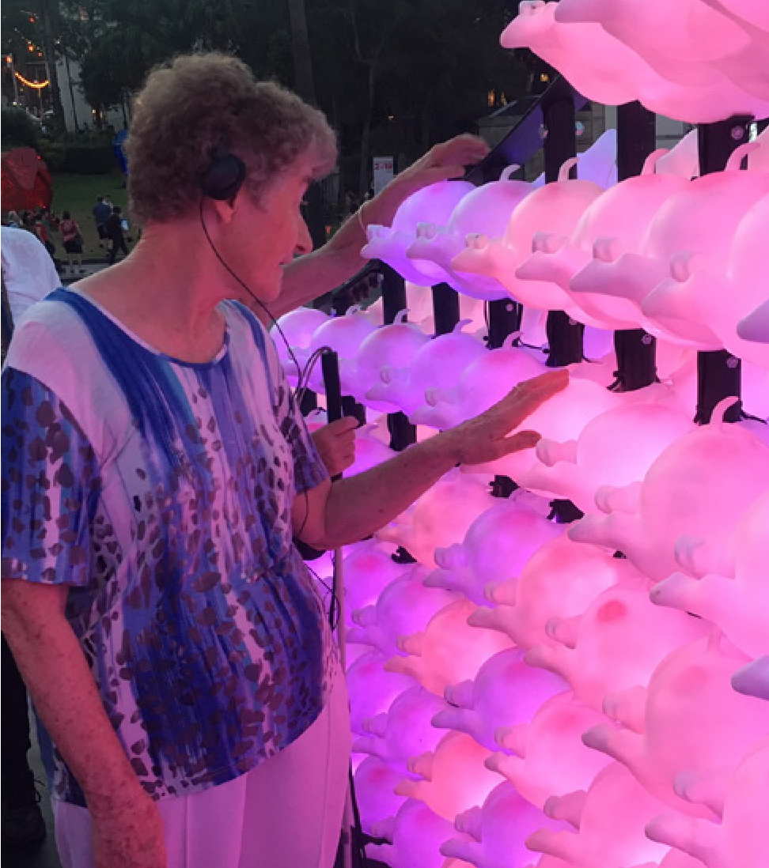
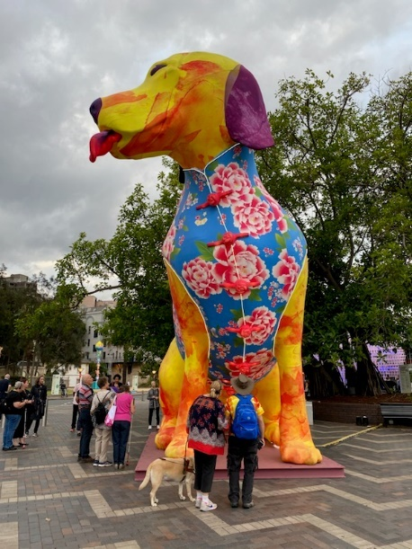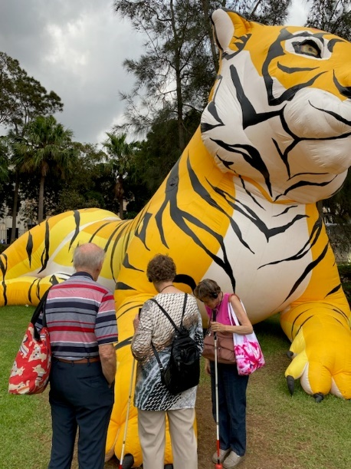
Photo 1: Large dog wearing Chinese outfit in the 2019 Lunar Lantern Exhibition
Photo 2: People participating in an audio-described tour of the 2019 Lunar Lantern Exhibition
Photo 3: Person exploring the tactile elements of the lanterns while listening to the audio described tour. Photographer: Joanne Chan

Making events inclusive of Deaf and hard of hearing people
When planning an event, it is important to understand that different accessible communication technologies benefit different people in different ways.
Auslan | Live Captioning | Hearing Augmentation
Auslan is the sign language of the Australian Deaf community. | Captions are created as an event takes place and are displayed on a screen. | Makes amplified sound easier for people with hearing aids to hear.
How it works  In an event or performance context, an interpreter translates speeches and other performances with spoken word into Auslan.  The interpreter is often on stage so people can see the translator and performance together.  Some interpreters specialise in interpreting music but will need music and lyrics ahead of time to rehearse. | How it works  A professional captioner types all audio content on a device that publishes spoken words and sounds in text format.  The live transcript is displayed on any screen at the event by accessing a weblink. Captions can be open or closed. The captioner is either at the event or works remotely using an audio feed. | How it works  Transmits sounds from an inbuilt amplification system to the hearing aid of an individual. There are various types of hearing augmentation systems and hearing aid devices using different technologies.  Ask the facilities or venue manager for more detail when you book.
Auslan benefits the Deaf community  The community largely but not exclusively, includes people who were born Deaf and have grown up in Deaf culture. The 2021 Census estimated that 16,242 people use Auslan.  For many Deaf people, Auslan is their first language, and not all Deaf people are confident with English.  Auslan does not meet the needs of people with hearing loss. Most people with hearing loss acquire it as they age and are less likely to have learnt and or use Auslan. | Live captioning benefits most people with hearing loss  Not all Deaf people are fluent in English, so captioning does not always meet their needs.  Captioning can benefit the broader audience, particularly if acoustics are challenging at the venue, or speakers are hard to understand. | Hearing Augmentation  This benefits people who use hearing aids.  Not everyone with hearing loss uses hearing aids, and not all hearing aids are compatible with hearing augmentation systems.
When should it be provided?  Available on request for all events.  While demand for Auslan may not be as high as captioning for example, providing Auslan at events can be used to share Deaf culture with the wider community and foster better awareness and more positive attitudes towards people with disability.  If the event includes Auslan, make sure it is for all event proceedings (not just speeches). | When should it be provided?  Available on request for all events.  Where acoustics are poor.  For major events where feasible. Note, YouTube and Microsoft Teams can use speech recognition technology to automatically create captions for your videos. These automatic captions are generated by machine learning algorithms, so the quality of the captions may vary. | When should it be provided? Some indoor venues have hearing augmentation as a part of the requirements under the Disability (Access to Premises – Building) Standards 2010.  For outdoor events, you may elect to hire portable hearing augmentation systems – these are typically FM receiver based.
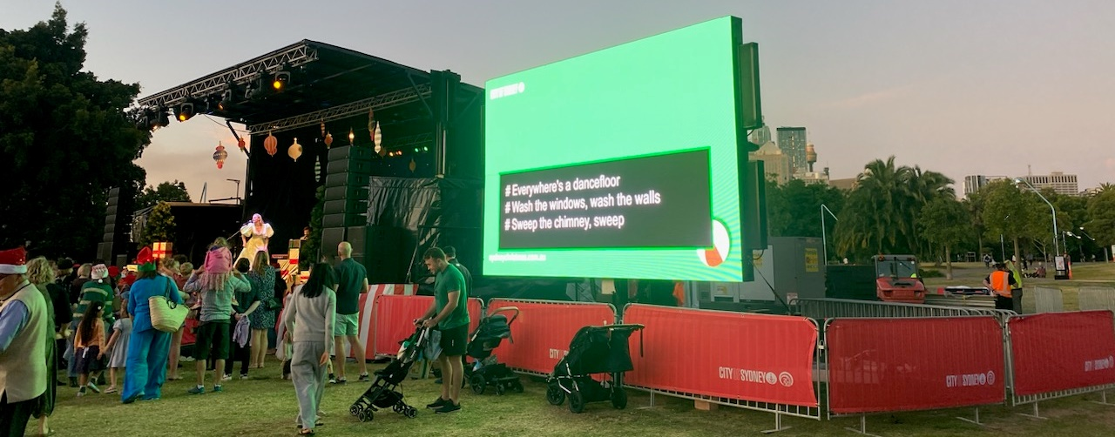
Photo: Live captions available at 2022 Christmas Concert. Photographer: Joanne Chan

Making events inclusive for people with Autism and other sensory processing disorders and mental health conditions
A sensory space is a designated area at an event or venue. It is specifically created with tools and equipment to help children and adults with sensory processing disorders regulate their senses, especially during sensory overload or a meltdown.
Sensory processing disorders are commonly (but not always) associated with being on the autism spectrum, also known as Autism or Asperger’s syndrome.
People with a sensory processing disorder can be particularly sensitive to light, sounds, textures, flavours, smells and other sources. Symptoms of sensory processing disorders may include hypersensitivity or hyposensitivity.
Hypersensitive (or oversensitive) people may have an unexpected response to loud noises and/or notice sounds that others do not. They may dislike being touched, even by people they know. They may be fearful in crowds and reluctant to participate for fear of being bumped into.
Hyposensitive (or under sensitive) people lack sensitivity to the surroundings. They might have a high tolerance for, or indifference to pain. They may be ‘sensory seeking’ meaning they have constant need to touch people or things – even when it is not appropriate. Others who are sensory seeking have a lower proprioception, or sense of their body in the world. This results in a person needing to spin, swing or use another form of movement to feel regulated.
In young children and some adults, these sensitivities can result in challenging behaviours, or severe withdrawal. Children and adults may experience a meltdown, which can be mistaken – particularly by onlookers as a temper tantrum, challenging behaviour or even intoxication.
For many children and adults with sensory processing disorders or mental health conditions, such as anxiety, having access to a sensory room means they have a safe space of their own where they can go to feel regulated and calm.

Sensory spaces
Sensory spaces can be places of sensory stimulation and/or sensory de-stimulation.

Quiet space (sensory de-stimulating spaces)
A quiet space is specifically used for people who need to avoid sensory stimulation (including some people with Autism) and people who may become overwhelmed in certain busy event environments, for example, people with anxiety.
Key features of a quiet space include:
- a space like a tent or room, where the person can get away from noise, light, sound, other people and other stimuli
- providing noise cancelling headphones to people who are overstimulated by noises
- using calming lighting within a venue
- making comforting blankets and pillows available.

Sensory stimulating spaces
Key features to include for sensory stimulation include:
- fidget toys, like fidget spinners – to allow people to satisfy the desire for constant movement
- weighted toys and blankets
- toys and books with stimulating textures, such as sequins or knots.

Sensory adjusted performances
Sensory adjusted performances are designed to create a performing arts experience that is welcoming for people on the autism spectrum, or for others with disabilities that create a sensitivity to sensory input.
Often the lights are turned on and the sound is turned down, so children and adults can dance, walk, yell or sing!
As with all children, it is important that kids with Autism or other disabilities are exposed to different situations in order to broaden their experiences. But visual and verbal prompts are key to helping them cope with and enjoy these experiences. Features of sensory adjusted performances can include:
- Relaxed environment – a relaxed and safe environment with limited crowds and visitors and extra staff to help as well. The most important aspect of these types of performances is that it’s a non-judgmental environment, especially if children are exhibiting challenging behaviours. Parents and carers can relax and worry less about disturbing others.
- Modified sounds – lowered sound levels throughout the performance benefit children who are sensitive to loud noises.
- Adjusted lighting – low lighting, especially lighting focused on the audience, helps some children who have difficulty taking in sensory input such as bright lights.

Nanushka Tam Tam
A quiet space can create calm for neurodivergent people

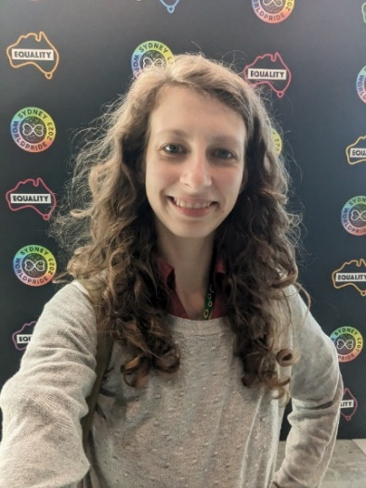
Photo: Nanushka smiling at the camera at Sydney WorldPride
Handy tip: By recognising their own needs and advocating for themselves, Nanushka was able to participate in the conference and benefit from the experience. The conference's provision of a sensory-friendly quiet space and willingness to accommodate Nanushka's needs demonstrates a commitment to inclusion and accessibility for neurodivergent individuals.

Nanushka is a 28-year-old autistic, ADHD and dyslexic individual who attended the Sydney Human Rights Conference as part of Sydney WorldPride at the International Convention Centre. The conference offered a variety of events and sessions focused on promoting human rights, and included a sensory-friendly quiet space, a spiritual space and a First Nations space.
Nanushka is sensitive to sensory input, including lights, heights and noise, and experiences sensory overload easily at noisy events. During one of the sessions at the event, Nanushka began feeling dizzy and sick due to the input of light and sound. Recognising the signs of sensory overload, Nanushka decided to take a break and headed to the sensory-friendly quiet space. This space provided a low-stimulation environment, with reduced noise and lighting, which allowed Nanushka's sensory system to calm down within 10 minutes.
To further help regulate their sensory needs, Nanushka asked for earplugs and dimmed glasses. The conference staff were responsive to Nanushka's needs and provided them with the requested accommodations. With these tools, Nanushka was able to continue attending the event without further distress.
Overall, Nanushka was able to navigate the event successfully with the help of the accommodations provided and their own coping strategies

Best practice considerations
- Extra space – Since crowds are limited, extra space is available throughout the venue for standing, walking and dancing. This can benefit children who are sensory seeking and need to move to regulate.
- Quiet space or sensory space – Someone may be over stimulated from sensory input and need a quiet place to de-stress.
- A social story – Provided to parents to share with their children before the performance. Showing children what you want them to do and what is expected helps them prepare for the day.
- Sensory maps – These identify which places might be noisy, bright, dark, busy, have a strong smell, or where people might be able to go when they want to get away from these places, for example a quiet space or sensory space. These easy-to-read maps help people to understand the environment and prepare for the journey.
- Explanation of the ‘hidden curriculum’ – The ‘hidden curriculum’ is the type of behaviour rules that most people just seem to know for a certain situation or context. Some people with sensory processing disorders might need help understanding the types of things that are allowed and expected in the event context. These might include if people are expected to remain quiet during a performance or not, or if people are allowed to touch the art or if they can just look at it.
- Making non-visible disabilities visible – Some disabilities, conditions or chronic illnesses are not immediately obvious to others. For some people this can make it hard to understand and believe that someone with a ‘non-visible’ condition genuinely needs support. The sunflower lanyard can be worn by people with a non-visible disability to encourage inclusivity, acceptance and understanding.

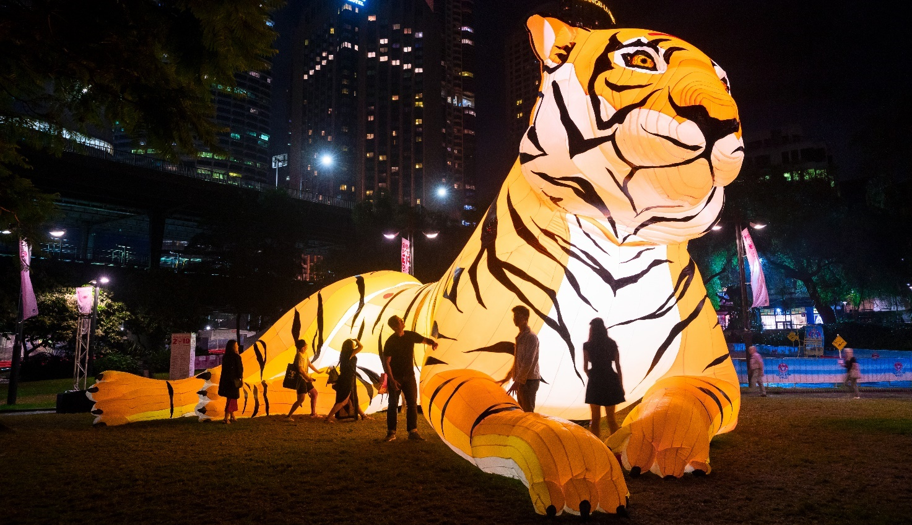
Photo: People exploring a tiger at Lunar Lanterns, Sydney Lunar Festival 2019. Photographer: Kevin Bathman

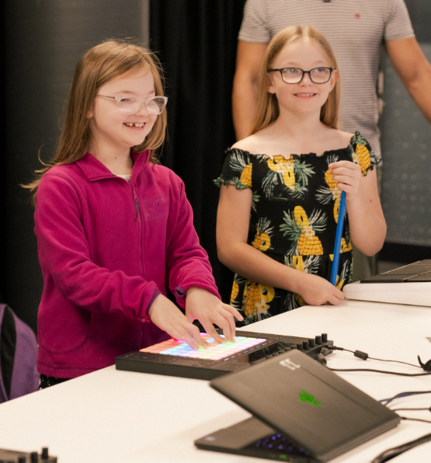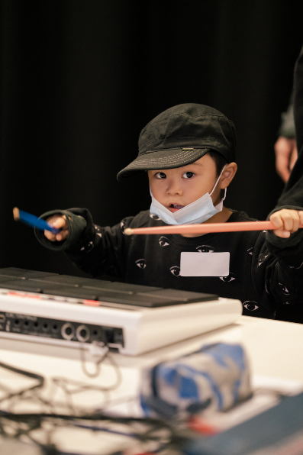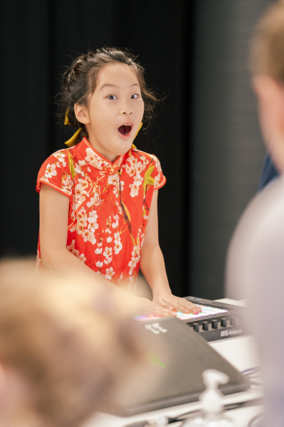
Photo 1: 2 young girls creating electronic music using an Ableton Push. Photographs courtesy of EMC / Photographer: Mark Broome
Photo 2: Young boy playing with a Roland electronic drumming kit wearing a black hat.
Photo 3: Young girl in a red dress playing an Ableton Push showing excitement on her face.

Case study: Lil Peeps, Big Beats
Electronic Music Conference (EMC) organised a fun, therapeutic and electronic music therapy experience for children with disability, their parents and carers at the Powerhouse Museum in April 2022.
EMC worked with Accessible Arts, TunedIn Music Therapy, Ableton and Roland, engaging music therapists, music equipment specialists and creatives with lived experience of disability to work on creating and producing the program. The free music workshop event was a great success with 90 participants, including 45 children and 45 parents/carers – catering for all accessibility needs. It was mainly attended by children with autism spectrum disorder and/or attention deficit hyperactivity disorder.
Accessibility features included a wheelchair accessible venue, the hidden disability sunflower lanyard support, entry hosts that had completed Accessible Arts disability confidence training and targeted promotions to specialist disability schools and community groups.
Handy tip: Collaboration was key to successfully producing this pilot program. The co-design between music therapists and product specialists was critical to ensuring an engaging participatory experience for the children and their parents/carers. Accessible Arts was a vital partner to work with EMC on the outreach to adult music practitioners with lived experience of disability.

- Accessible materials and information
Historically, the needs of people with disability have not been considered at many events. People with disability have too often had bad experiences and are unwilling to go somewhere unless they know beforehand that their needs will be met.

Good quality information
People with disability rely on quality information about an event to understand if it is accessible to them or not. They will be looking for information that tells them:
- how they can get there
- if they can move around independently or safely
- how they can join in, participate or experience the event
- if they can access food, drinks and toilets with independence and dignity.
Good quality information helps people with disability to participate with confidence. It is important to actively promote what’s on offer so people with disability are aware and feel welcome.
If your event has its own website, develop a dedicated accessibility webpage that outlines all access features of the event and is easy to find from the main page.
The web page should be digitally accessible and compliant with the WCAG 2.2 standards:
- All downloadable documents should be made available in alternative formats (at a minimum Word version formatted for accessibility), you may also consider large print, audio, captioned video, or Easy Read versions.
- The online booking system should allow people to book accessible seats and request support without having to speak to someone.
- The website should include a contact phone number and email to speak with a trained customer service attendant or event organiser that can answer accessibility questions and respond to requests.
The following information should be included on a dedicated event website.

Getting there
- Nearest accessible public transport location
- Available parking and accessible parking onsite
- Nearest on-street mobility parking and/or commercial car park with accessible parking
- Nearest accessible drop-off and pick-up area
- The location/names of roads and lifts that may be closed or affected that will impact travel on the accessible path to the event

Venue accessibility
- Maps that include key event destinations, accessibility infrastructure and the continuous accessible path of travel
- Accessible seating and viewing areas
- Accessible toilet locations
- Accessible adult change facilities

Opportunities for inclusive participation
- If hearing augmentation, Auslan interpreting, captioning, audio description and tactile tours are provided
- If other supports are provided – such as quiet spaces or sensory adjusted performances

Booking information
- How to book for any access features, including dedicated drop-off areas, accessible viewing areas, or sensory adjusted performances
- If the Companion Card is accepted (for paid events)

Contact information
- How to contact the event organiser to discuss access needs – including email, contact number, and the National Relay Service
- Contact details for assistance on the day
- Use relevant accessibility icons to help communicate features
- If your event does not have its own website, but uses event listings and registration pages, at minimum include information about venue accessibility and how to contact the event organiser to discuss access needs (consider using the free City of Sydney What’s On Guide and listing the accessibility features of your event)
- For major events and festival or regular events, consider having a dedicated access and inclusion officer for the event that can champion, promote and offer support for people with disability
- Provide an option for people with disability to leave access and inclusion feedback for events – sometimes the best ideas for future inclusions at events come from customer feedback

Sabrina Houssami
Photo: Sabrina smiling at the camera enjoying Sydney WorldPride.
"I have to be able to understand what's going on – so if an event doesn't meet my access needs, I just won't attend."

Would you watch a foreign film without the subtitles on? That's what it's like for me, as a hearing-impaired woman, when an event isn't captioned.
I wear hearing aids in both ears, which means I can hear sound. But I can't capture clarity. So at a noisy concert, I have no idea what people are saying on stage, or what the words to a new song might be.
I recently went to Sydney World Pride's Rainbow Republic concert and literally cried when I saw that they were captioning every single word on a big screen above the stage.
Suddenly, I could understand! I could engage. And I noticed everyone else around me paying closer attention to the speakers as well – reading those captions along with me – because let's face it, it's hard for most people to hear at a big old party!

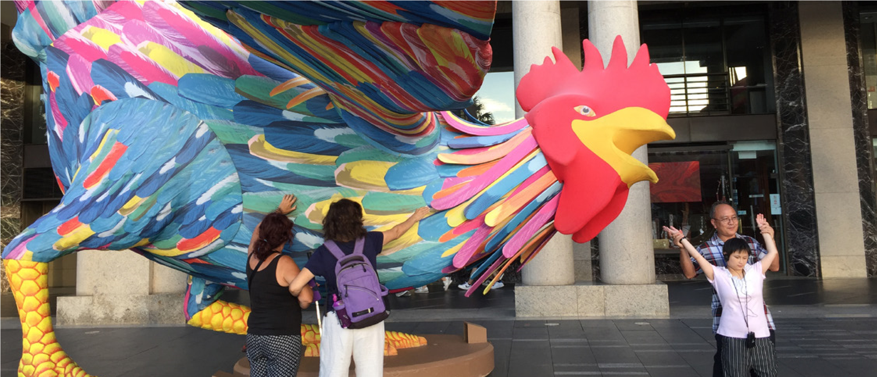

Photo: Two ladies touching a large colourful rooster at Sydney Lunar Festival 2023. Photographer: Joanne Chan

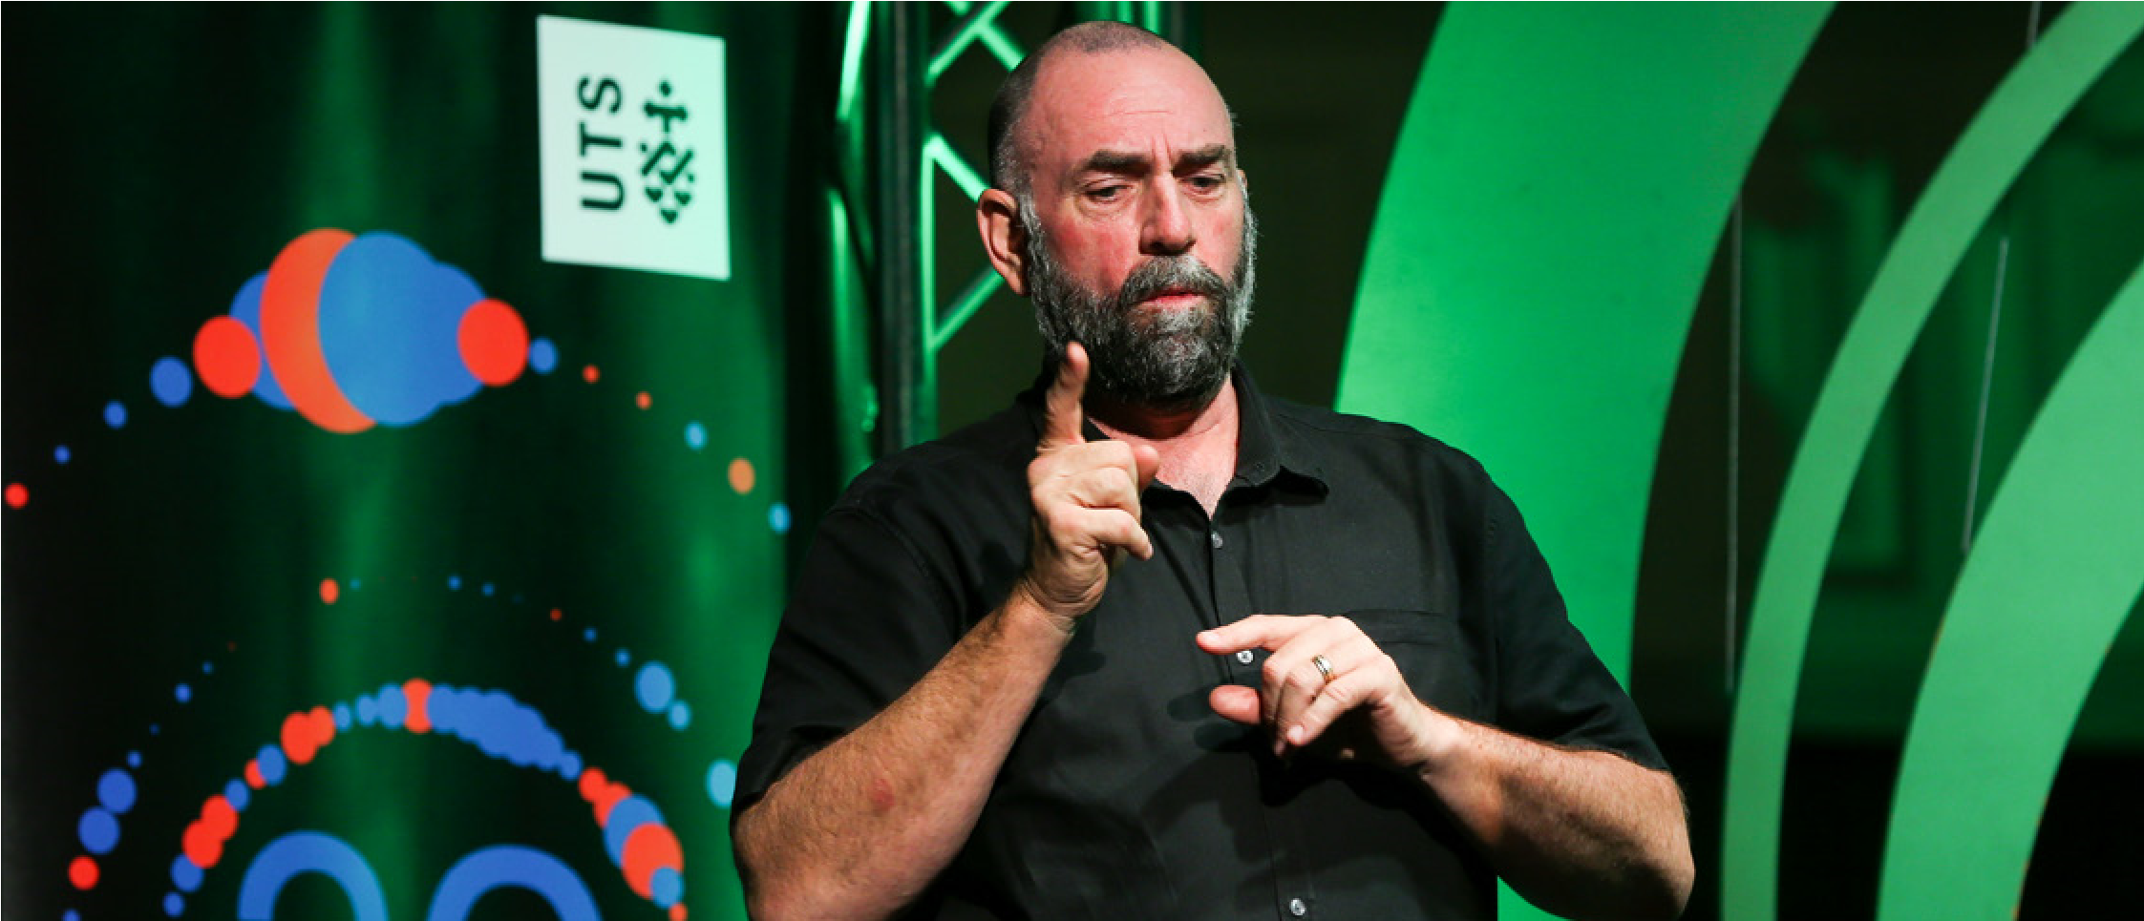
City Talks featuring Auslan interpreter. Photographer: Katherine Griffiths

Communications and marketing
Now that your event is accessible, and includes opportunities for inclusive participation, it’s important you communicate and promote these features of your event.
Your event communications, such as invitations and flyers, should at minimum:
- ask participants to notify you about any specific accessibility support needs or requirements
- communicate specific access services and opportunities for inclusive participation (where provided)
- provide direct contact details, should people need to ask questions about accessing the event – including a direct telephone number, email address and website.
When promoting your event through digital communication channels, avoid using PDF invitations only. Instead use accessible HTML formats, Word documents, accessible PDF files or plain text. This will assist people who use screen readers to access information.
Recommended inclusion statement for events
We aim to produce inclusive and accessible events. If you have any particular access or communication needs, please contact <insert name and role> on < insert phone number and email address>.

Best practice considerations

Print accessibility
Make your print communications as accessible as you can:
- use plain English
- use a sans-serif font
- aim for 12-point font size (11 is the absolute minimum)
- avoid using all capitals and italics
- make sure there is effective colour contrast between background and key information text
- make sure text is horizontal and straight (not vertical)
- use accessibility icons
- use photos or images to help describe the event.
Provide alternative formats on request – it’s law. Other alternative formats include large print, Easy Read, Auslan video, captioned video and audio.

Actively promote to people with disability
People with disability are used to events not being accessible to them. If you have gone to the effort to make the event inclusive and accessible, make sure you actively promote your event to disability organisations and peak bodies. Some strategies include:
- email details of your inclusive event to local disability services and/or peak bodies
- promote your event on social media and tag local disability groups and service providers
- some disability groups and service providers have regular electronic newsletters and you may be able to promote your event in their newsletter – please note, this may involve a fee
- promote your event on our What’s On website
- send information about your event to local newspapers and list it on their websites.

Case study: Limitless – Sydney Fringe Festival

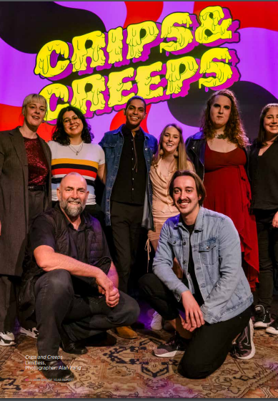
Photo: Inclusively curated Crips and Creeps diverse cast members posing and smiling for the photo. Photographer: Alan Fang

Handy tip: Training is crucially important to continue to develop skills and understanding of access and inclusion and provide a great customer experience. In 2022 specialist training was undertaken by key staff as well as venue staff and volunteers briefed in access and inclusion and disability confidence. Independent producers also received information packs and the ongoing support from the access coordinator.

2022 saw the Sydney Fringe Festival launch its accessibility hub – Limitless. The 2-week micro festival based at 107 Redfern celebrated and supported D/deaf and Disabled artists and audiences, with 176 artists with disability involved.
A dedicated access coordinator managed the micro festival, which included 8 performances showcasing diverse performers and styles and 5 visual artists. The disability and inclusion advisory panel provided guidance and an accessibility handbook was published and distributed, along with a free online Access Masterclass.
Provisions included an accessible venue, a sensory chill out space, audio-described gallery tour, Auslan interpreters, captioning and relaxed performances. Social events, such as the opening night party and visual artists Q&A provided networking opportunities for artists, and overwhelmingly positive feedback was received from the audience, producers and performers.

Tara Elliffe

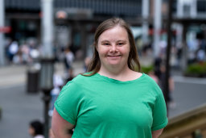
Handy tip: Accessible information for pre-planning is important. This should include being available in Easy Read before the event for me to be able to understand what is available and decide if I’d like to go.

I love to get out and about and attend different events in the city. What is important for me is to have information available in Easy Read.
If information is available in advance in Easy Read or plain English with photos or images, it helps me to understand what to expect at events and where to go to find what I need, such as getting there safely by public transport, or where to find food or toilets.
Having friendly staff to help if I get lost or need support at an event is important – it can make the difference between a good or bad experience.

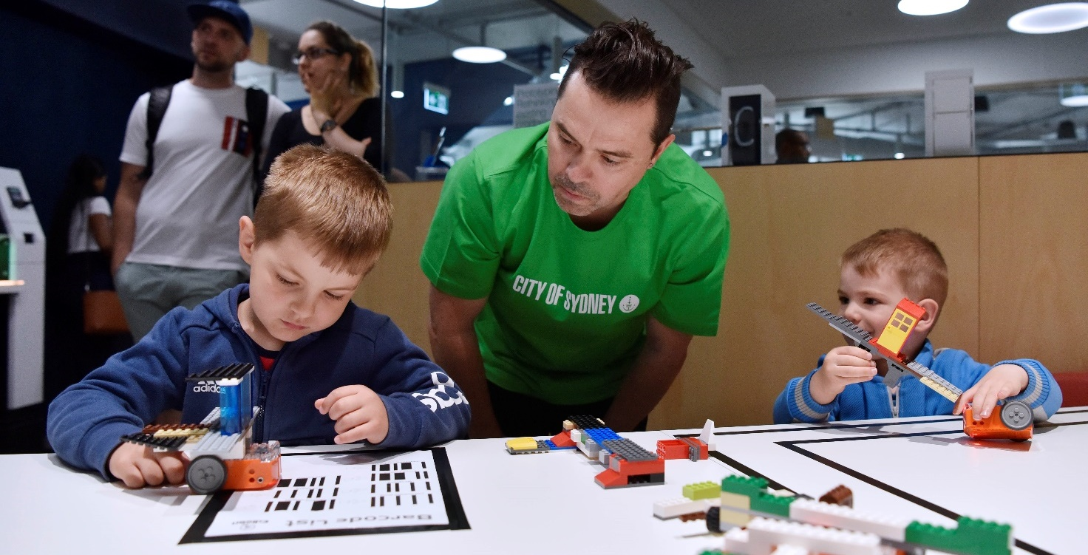
Photo: Children playing with Lego at the Darling Square library in 2019. Photographer: Adam Hollingworth

Employee attitudes and awareness
WELCOME
People with disability will feel sure that employees and volunteers at the event will be able to help them if they need assistance if they are disability confident.

Minimum requirements
All employees and volunteers preparing or participating in an event, including contractors such as security and catering, should be briefed about key access features including:
- appropriate language and strategies for communicating with people with disability and offering help respectfully
- viewing area locations, accessible facilities, paths, ramps, entrances and exits, lifts and other features
- captioning availability, Auslan interpreting, audio description and/or assistive listening technology such as hearing loops
- information about both the accessible and inaccessible features of the event activities and performances
- emergency evacuation procedures for everyone, including requirements of people with disability
- an understanding and awareness of assistance and companion animals, particularly Guide Dogs – further information on what to consider can be found on the Guide Dogs NSW/ACT website.

Best practice considerations
All major events should:
- provide employees with disability awareness training and consider annual training refreshers
- consider Deaf awareness training
- consider Autism awareness training
- make sure at least one event employee has a Mental Health First Aid Certificate
- where there are dedicated access officers or employees with specialist knowledge, make sure other employees and people with disability attending the event have contact details for them if there are issues on the day.

Why is this important?
- Low levels of disability awareness and negative views about people with disability are one of the main barriers to participation.
- Sound disability awareness and employee attitudes increase the satisfaction and the likelihood of people with disability attending an event or service again.
- Good access is good for business and responsible organisations that promote access and inclusion are rewarded with loyal customers and enhanced branding.
- Universal access improves access for everyone, including parents with prams and people with limited mobility. Improving access and inclusion is linked to increased customer satisfaction.
Remember
Each person is different. What works for one person may not work for another, even if both people have the same disability.
While it is important to plan events to be as inclusive as possible, being flexible, respectful and asking people if and how you can help will go a long way.

Inclusive language and communication
Language is a powerful tool for inclusion. The following terminology is sourced from peak groups that work with and represent people with lived experience of disability.
Language and community expectations are constantly evolving. One label or description may not capture the breadth and depth of different groups, and descriptions may also change over time.
Remember
– Always focus on the person not the disability
– People with disability are experts in their own needs – so when in doubt ask
– Don’t stress – be respectful and flexible

Principles for inclusive language
- Use person first language – for example, ‘person with disability’ or ‘people with disability’.
- Identity first language is commonly used – for example, ‘I am Disabled’, ‘I am Autistic’ or ‘I am Deaf’.
- Disability is not a dirty word – it’s ok to use words and phrases such as ‘disability’ or ‘people with disability’.
- Avoid euphemisms as they can be patronising – such as ‘all abilities’ or ‘differently abled’.
- Avoid language such as mental, crazy, mad, psycho, spaz, impairment, handicapped, special needs, afflicted, and vulnerable – this language is offensive for people with disability.
- It’s ok to use common expressions – such as ‘see you later’ to a person who is blind or has low vision or ‘walk to the station’ to a person who uses a wheelchair.
- What’s normal anyway? – when talking about people without disability don’t refer to them as ‘normal’ or ‘healthy’, instead use ‘people without disability’.
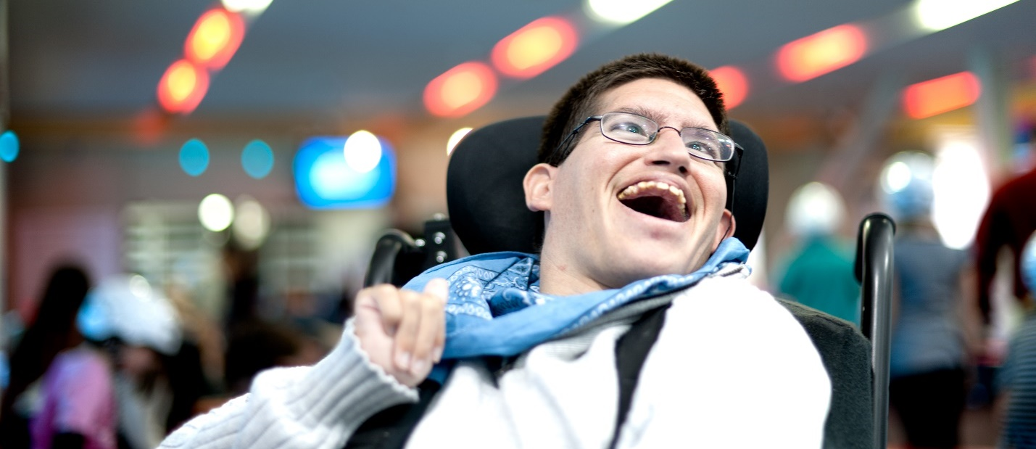
Photo: Person using a wheelchair smiling at the camera. Photographer: Gary Radler

Disability etiquette
- Face and speak directly to the person with disability. It is disrespectful to speak to their friend or carer instead, as it makes them invisible when they can speak for themselves.
- Establish and maintain eye contact at the same level as the person you are speaking with, this is polite and respectful.
- Don’t ask personal questions that aren’t relevant or make assumptions.
- If you don’t understand what a person is saying, tell them, and ask them to repeat or rephase what they said.
- Ask a person who is blind or has low vision if and how they would like to be supported or guided. When approaching introduce yourself, see if they would like assistance and never leave them without telling them.
- Do not touch or ‘help’ a person with a mobility aid unless they ask for assistance. If they are struggling ask if they would like assistance, and don’t be offended if they say they don’t need help.
- Do not refuse a Guide Dog or assistance animal at an event – it’s illegal. Do not pat, play with or distract the animal.
- The sunflower lanyard is a globally recognised symbol for a person with a non-visible disability to let people know they may need understanding, support, guidance or patience. For example, they may have a sensory disability and may experience sensory overload or a meltdown.
- Be observant and understanding if people are having communication difficulties. Be patient and ask how you may help and listen to their instructions.
- People with disability aren’t there to inspire us or be ‘inspiration porn’ – they are living their lives, like any other person.
- Disability is not a burden to overcome – it’s a normal part of life with one in 6 Australians having a disability.

Online events
While Microsoft Teams and Zoom let people connect remotely, it’s important to ensure people with disability are able to participate by carefully considering access and inclusion for online events.

Minimum requirements
- Ensure video conferencing or webinar software is accessible, you must comply with Web Content Accessibility Guidelines (WCAG 2.1 AA, soon to be updated to WCAG 2.2);
- Ask all participants if they have any access requirements before the meeting or event
- Provide a phone-number or dial in method for people who don’t have access to a computer or internet
- Provide the agenda or event materials in the preferred accessible format before the meeting or event
- Nominate a person to contact for help before and during the meeting

Best practice considerations

Planning and preparation
- Plan for diverse access requirements. For example, live captioning and/or Auslan interpreters for people who are d/Deaf or hard of hearing, audio description for a person who is blind or has low vision, Easy Read and/or a support person for a participant who has an intellectual disability. Promote and let people know the access you are providing.
- Think about the format. Consider a variety of communication and information styles and provide a variety of ways people can engage with your event online, for example live chats, activities or break out rooms.
- Think about length and time. Online events can be tiring for some so consider shorter sessions and regular breaks. The time of the event can also impact participation.
- Provide event materials in the preferred accessible format before the meeting or event to help people who may need extra time to read the material.
- Representation matters. Access is also about what you program, who you invite to speak and what your content is. Consider involving people with disability in designing and shaping the program and to share their diverse experience and views.
- Be sure to test any software before the meeting and be aware that software requiring download beforehand may create barriers for access and inclusion.

Hosting the meeting or event
- Nominate a person to contact for troubleshooting and technical support throughout the meeting.
- Make sure participants are aware of the accessibility features you are using and how to access them, for example, to turn on live captions or how to ‘pin’ the Auslan interpreter to the screen.
- For PowerPoint presentations, make sure the font is san serif and the size is no smaller than 12 point, ideally 18 point.
- Make sure there is a good colour contrast between text and background.
- When presenting and using pictures, maps and slides, it's best to verbally describe the content and have people introduce themselves before speaking so that people with low vision are fully informed and included.
- Use plain language to increase accessibility for a variety of audiences.
- Make use of the chat function allowing participants to ask questions or request clarification, particularly for those not able to speak.
- Silence all participants or ask participants to mute themselves to minimise background noise.
- Check in regularly with participants and repeat or paraphrase any questions which may be difficult to understand or placed in the chat.
- Hybrid meetings (both in-person and online) can be difficult to participate for people joining online. Make sure you have considered microphones and audio for in-person participants and regularly check online to facilitate participation.

After the meeting or event
- Enhance access and inclusion, by sharing the video recording, transcript or minutes, or follow up with participants who requested accessibility requirements to ensure they were met.
- Ask for feedback through a survey to see what worked well and what can be improved. Make sure the survey is in an accessible format.
- If possible, allow participants the option of sending further thoughts or feedback by email or phone after the meeting. This can assist people who require more processing time.

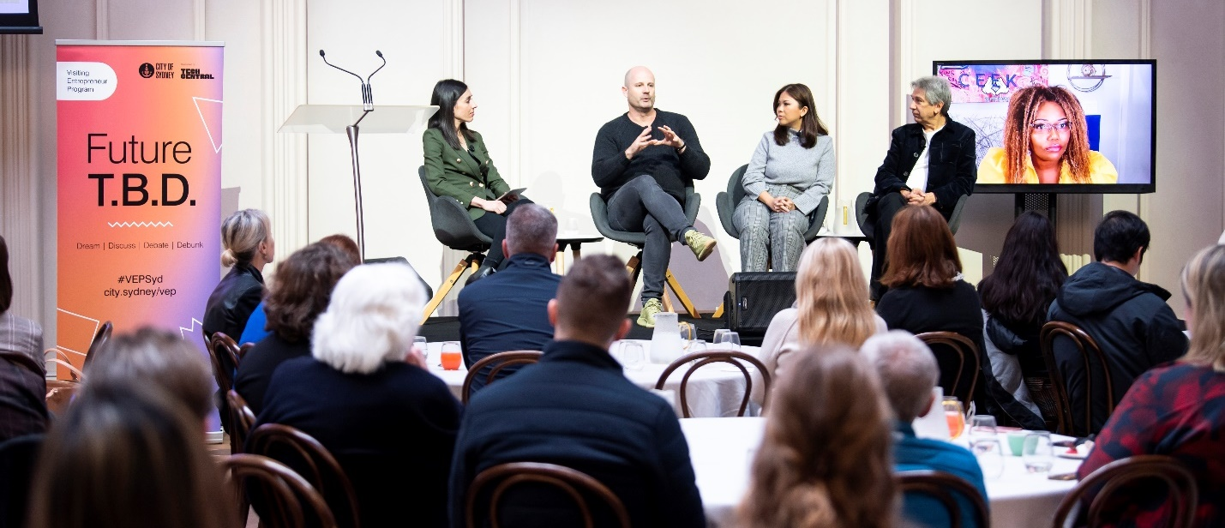
Photo: A panel of speakers on stage participating in the 2022 Visiting Entrepreneur Program. Photography: Cassandra Hannagan

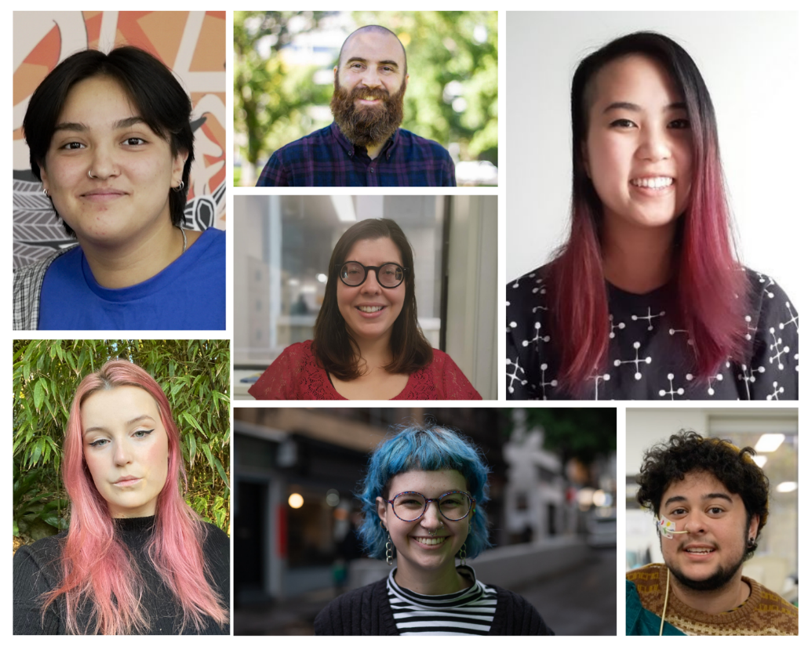
Photo: A photo of the Youth Disability Advocacy Services (YDAS) team of young people with disability. Photographs courtesy of YDAS.

Case study: Together – Access and inclusion online training workshop
The workshop aimed to provide disability inclusion and awareness training as part of the City of Sydney’s program for International Day of People with Disability 2023.
Participants built confidence, skills and knowledge to better communicate, engage and work with young people with disability. The program was designed and facilitated by young people with lived experience of disability from the Youth Disability Advocacy Service. Participants learnt about; assumptions and asking questions, models of disability, language and context around disability, accessibility in practice and tools for accessibility.
“The disabled young facilitators are fantastic trainers and very generous in sharing their own experiences. Thank you very much for this thoughtful and thorough training, I learnt a lot. I liked that this training was developed in consultation with young people with disabilities, so we were hearing their voices and perspectives”.
Accessibility and inclusion features that were provided included an online registration process asking people if they had access requirements, contact information to provide support for registration and attendance, captioning, content warnings and shared lived experience, regular breaks and check-ins with participants.
Handy tip: When planning and producing online events, it is important to involve young people with disability in the planning process (and pay them for their time) to ensure the programs you are running are accessible and inclusive from the beginning.

Checklists
The following checklists outline the minimum and best practice requirements for inclusive and accessible events.
- The minimum requirements provided are designed for all events to include a continuous accessible path of travel, appropriate supply of accessible toilets, a single point of contact for accessibility enquiries and good information about accessing the venue and event.
- The best practice considerations are those the City of Sydney encourages all event organisers to achieve where possible.

Accessible venues and spaces
Task | Minimum | Best practice | Yes/No/ N/A | Comments
Accessible entrance
Step free entrances to venue
Lift access for events not on the ground floor
Ramps are no steeper than 1 in 14 incline (refer to Australian Standard 1428.1)
Continuous accessible path of travel | (indoors)
The continuous accessible path of travel has:
- no steps, turnstiles and obstructions such as signs and stalls, furniture or temporary infrastructure such as power cabling or art installations
- a minimum 1000mm wide clearance
- a minimum of 2000mm height clearance.
Continuous accessible path of travel | (Outdoor)
The continuous accessible path of travel has:
- no steps, turnstiles and obstructions such as signs and stalls, furniture or temporary infrastructure such as power cabling or art installations
- a minimum 1200mm wide, with 1800mm pass spaces every 20m
- a minimum 2000mm height clearance.
Event infrastructure (stalls, toilets, drop-off areas) are located to take advantage of existing accessible footpaths and kerb ramps
Stalls, signs and traffic control barriers do not block existing kerb ramps
All pathways are continuous, with no breaks or gaps
Where there are stairs, the alternative step free route is indicated
People responsible for bump in and bump out are aware they must not block the continuous accessible paths of travel
Temporary art installations do not obstruct the continuous accessible path of travel

Accessible toilets
Minimum 1 wheelchair accessible toilet per 10 standard toilets, meeting requirements of AS1428.1
Accessible toilets are not locked or used as storage
The outdoor portable toilet is near the continuous accessible path of travel and on a level ground via ramp
Accessible adult change facility
Accessible adult change facility has a hoist and adult change table and meets requirements of AS 1428.1
Accessible adult change facility is not locked or used as storage
The outdoor portable accessible adult change facility is near the continuous accessible path of travel and on a level ground via a ramp
Accessible temporary structures
Temporary structures have been designed and installed in consideration of the Australian Building Codes Board’s ‘Temporary Structures Standard (2015)’
Where the main entrance to the temporary structure is not accessible, signs show the location of the accessible entrance.
The accessible entrance is also clearly signposted.
Temporary structures are accessible by ramp or stair lift.
Wayfinding and signs
- Provides good visibility/contrast between one surface or component and another surface or component. Refer to Vision Australia’s Colour Contrast Analyser to determine whether the colour selection is appropriate.
- Uses large sans-serif font
- Avoids the use of all capital text (capitalise the first letter)
- Uses directional arrows and symbols
- Provides direction to key event destinations such as, information areas, performance areas and food service areas
- Provides direction to accessible infrastructure such as accessible toilets, and accessible seating and viewing areas
- Is located at destination points to confirm location
- Is located where at a height that can be seen from a distance

For major events:
- signs including venue maps are provided at entrances and exits, as well as in promotional materials and on websites
- employees and/or volunteers have been appropriately briefed and can provide wayfinding assistance to people, in particular key accessible paths, destinations and key infrastructure
- maps and event signs show the continuous accessible paths of travel and key destination points and accessible infrastructure, such as, accessible toilets and accessible drop-off and pick-up areas
Mobility parking and public transport
There is a step free continuous accessible path of travel between key transport hubs and drop-off and pick-up areas at the event
Where appropriate, there are regular rest points along the walking route, every 50-75m
Accessible public transport options have been identified, where available
Alternative transport options (such as buggy service, community transport) is available for people with limited mobility, chronic illness and older people
Information about onsite accessible parking or the closest on-street mobility parking bays and commercial parking stations with accessible parking is provided as part of event access information
Drop-off and pick-up areas have been established near the entrance of the venue or space, and clearly identified
Emergency exits
Use accessible communications, such as visual alerts as well as audio
Employees are briefed on emergency exits, and a plan to assist people with disability in the event of an emergency has been developed and communicated

2: Opportunities for inclusive participation and experiences
Task | Minimum | Best Practice | Yes/No/N/A | Comments
Accessible seating and viewing areas
Seating for people using wheelchairs is dispersed with non-wheelchair spaces
Where wheelchair accessible seating cannot be dispersed within general seating, designated accessible viewing areas are available. These viewing areas are:
- located adjacent to a continuous accessible path of travel
- clearly indicated on the event map
- promoted on the event website and if possible available for booking
- inclusive of friends and family of people with disability
- are described as an ‘accessible seating or viewing area’ – not disabled or wheelchair areas.
People who are d/Deaf or hard of hearing are able to choose seats that are in a location with clear sightlines to Auslan interpreters and screens with captioning
People who are blind or have low vision are able to be seated near presenters, stages or performance areas where it is better to hear
A quiet space has been provided near the event or activity
Some if not all seating has back and arm rests
Rows of seats have enough space between them for people to manoeuvre between them comfortably
The above features have been communicated to venue employees, including booking operators and security so they are aware and can help people find the best seat
Accessible service areas
Service areas have:
- accessible counter heights of approximately 800-850mm, or
- more staff available to assist people with disability in accessing services that may be located behind the service area
- signs are legible and use:
  - minimum 18-point size font
  - sans serif font
  - single spacing between lines
  - different font sizes to distinguish between headings.
Temporary and moveable furniture
All (or at least some) seating has back and arm rests.
There is good circulation space (minimum 1200mm around and between dining settings)
At least 25% of tables are accessible for wheelchair users
Furniture has good colour contrast
Hearing loops (within the venue facility) or portable hearing loops (for outdoor events and activities) and signs are available
Microphones will be used to help people who are hard of hearing
Accessible communications
Spoken content (including on video) will be captioned and displayed on large screens or via tablet

Audio description of visual elements like performance, art, fireworks and video content

Auslan (Australian Sign Language) interpretation is provided for spoken word, such as talks, speeches or performances
Sensory spaces and considerations
Sensory adjusted performances for people and children on the autism spectrum
Quiet space or sensory space is provided, along with noise cancelling headphones and dimmed lighting
A sensory map identifying places that are noisy, bright, dark, busy or have a strong smell is made available
Non-visible disabilities
Employees are aware that people displaying a sunflower (lanyard or badge) have a non-visible disability and may require additional support
A social story is provided that provides information on what to expect at the event to help people prepare
Charging points
Charging points are available for people who use mobility scooters to recharge their scooter.
Guide Dogs and assistance animals
Staff are aware to allow Guide Dogs or assistance animals at the event and not to pat, play with or distract the animal

3: Accessible materials and information
Task | Minimum | Best Practice | Yes | No | N/A | Comments
Online information
Online event information is digitally accessible | All government agencies must make sure ensure all digital communications comply with WCAG 2.1 Web Accessibility Standards, soon to be updated to WCAG 2.2
Downloadable documents are digitally accessible and available in alternative formats on request
Information outlining key access features of the event and contact details for people to seek further information have been provided on the dedicated accessibility web page and/or within invitations, event listings and registration pages
The online booking system allows people to book access spaces and support requirements without having to speak to someone
Alternatively, if the system does not allow for this contact details have been provided so that it can be over phone or email
The event website includes information about:
- nearest accessible public transport location
- onsite parking and accessible parking where available
- nearest on-street mobility parking and/or commercial car park with mobility parking
- nearest accessible drop-off and pick-up area
- the location/names of roads and lifts that may be closed or affected
- accessible seating and viewing area, and information on booking requirements
- accessible toilet locations
- if hearing augmentation, Auslan interpreting, captioning and audio description will be provided
- wayfinding map with key event destinations, accessibility infrastructure and accessible continuous paths of travel
- relevant accessibility icons
- alternative methods to contact event organisers, including email and contact number.
- contact details for assistance on the day
- clear maps that include accessibility features to assist people with disability to plan and participate with more independence and dignity
Marketing and invitations
Marketing and invitations are in accessible format:  - plain text emails  - HTML email – where images are included with appropriate alt text  - Word document formatted for accessibility  - PDF file formatted for accessibility  - PowerPoint documents formatted for accessibility | All government agencies must make sure ensure all digital communications comply with WCAG 2.1 Web Accessibility Standards, soon to be updated to WCAG 2.2
Print invitations and marketing materials have:
- minimum 12-point size font
- sans serif font
- single spacing between lines
- don’t use all capitals (use upper and lower case) and italics
- effective colour contrast between background and key information text
- text horizontal and straight (not vertical)
- accessibility icons
- use photos and images to help describe the event
- advertise acceptance of Companion Cards.
Contact details (including phone number, email address and website) of a person who can answer questions about access is available on flyers, websites, invitations and event registration pages
Marketing materials and invitations include statement asking attendees if they have any specific accessibility support needs or requirements
Marketing material and invitations are sent to disability organisations and peak bodies
Applicable accessibility icons have been used on the City of Sydney What’s On website
Emergency information
Designated employees or appropriate emergency services have been briefed to provide additional assistance for people with disability during an emergency or evacuation.
The accessible emergency exit routes and exits are included on event guides, site maps and wayfinding, and designated employees are aware of these paths

4: Employee attitudes and awareness

Task | Minimum | Best Practice | Yes | No | N/A | Comments
Employees, volunteers and contractors such as security and catering have received basic induction for appropriate language to use when communicating with people with disability and have been briefed about the key access features of the event.
For example:
- locations of viewing areas, accessible toilets paths, ramps, entrances and exits, lifts and other features
- availability of captioning, audio description and/or assistive listening technology such as hearing loops
- availability of Auslan (Australian Sign Language) and the most appropriate viewing locations
- information about both the accessible and inaccessible features of the event
- emergency evacuation procedures for everyone, including requirements and considerations of people with disability
- Employees have completed disability awareness training, to highlight needs of people with non-visible disabilities
- at least one employee has a Mental Health First Aid Certificate
- A dedicated access and inclusion officer or staff member with specialist access or disability knowledge is part of the event planning team and can support staff and people with disability if any issues arise
- Their contact details have been provided as part of key marketing material and invitations
- Inclusive language and communication and disability etiquette provided in these event guidelines have been given to all event staff

5: Online events
Task | Minimum | Best Practice | Yes | No | N/A | Comments
Ensure video conferencing or webinar software is accessible | All government agencies must make sure ensure all digital communications comply with WCAG 2.1 Web Accessibility Standards, soon to be updated to WCAG 2.2
Ask all participants if they have any access requirements before the meeting or event
Provide a phone number or dial in method for people who don’t have access to a computer or the internet
Provide the agenda or event materials in the preferred accessible format before the meeting or event
Nominate a person to contact for help before and during the meeting
Think about the format, length and time and how it may impact participants
Use the chat function for people unable to speak
PowerPoint presentations
Make sure PowerPoint presentations:
- have minimum 12-point font size (ideally 18-point)
- have good colour contrast
- when presenting verbally describe content
- use plain language to increase accessibility.
After the meeting or event
After the meeting:
- share the presentation, video recording, transcript or minutes
- provide a feedback survey in an accessible format
- provide an opportunity for participants to send further thoughts or feedback by email or phone, as this can assist people who require more processing time.
Hybrid meetings
Hybrid meetings can be difficult for people with disability. Make sure consideration of audio, visuals and communication needs is undertaken into consideration beforehand and the facilitator is briefed to best enable participation

Resources
- Accessible Arts provides Top 10 tips for running accessible online events
- Australian Human Rights Commission has Guidelines on application of the Premises Standards
- Australian Network on Disability has resources on making accessibility a core principle
- City of Sydney has a Grants and Sponsorship Policy and Guidelines
- Disability (Access to Premises – Buildings) standards 2010
- Disability Standards for Accessible Public Transport 2002
- Guide Dogs NSW/ACT has information about handlers put in danger when refused access because of their Guide Dog.
- ICC Sydney has an accessible and inclusive events guide 2023 – 2025
- IncludeAbility has a guide for creating accessible and inclusive communications, a guide to hosting accessible and inclusive in-person meetings and events and a guide to hosting accessible and inclusive online meetings and events
- New South Wales Government has an event starter guide which include information on accessibility.
- Inclusive South Australia has an accessible and inclusive community events toolkit
- Meetings and Events Australia has an accessible events guide for meeting and events organisers.
- Mental Health First Aid Australia - Mental health first aid is the help provided to a person who is developing a mental health problem, experiencing a worsening of an existing mental health problem or in a mental health crisis. The first aid is given until appropriate professional help is received, or the crisis resolves. https://mhfa.com.au
- NSW Government, Public Service Commission, Inclusive online events guidelines
- Universal Design Australia has several guides for inclusive and accessible events.
- Victorian Government has an accessible events guidelines and checklist.
- Vision Australia has a colour contrast analyser
- WayAhead – Mental Health Association NSW provides mental health information – the WayAhead Directory, Mental Health Factsheets and information and education seminars; and runs anxiety support groups in NSW. https://wayahead.org.au
- Web Accessibility Initiative has information on WCAG2.1 at a Glance.
- Web Accessibility Initiative – What’s New in WCAG 2.2 Draft
- Web Content Accessibility Guidelines (WCAG 2.1)
- Web Content Accessibility Guidelines 2.2 W3C Candidate Recommendation Draft

Glossary
Term | Meaning
Accessible | Accessibility refers to something being easy to obtain or use, or physically being able to access a place or thing.
Accessible adult change facilities | A toilet and change facility that caters for users with high support needs and their carers where they require more space, assistance and specialised equipment (including a hoist and accessible adult change table) to allow them to use toilets safely and comfortably.
Access and mobility map | A walking route map that includes information such as continuous accessible path of travel and the location of access features such as accessible toilets. It can also indicate physical barriers such as stairs and steep hills.
Accessible communications | Accessible communications (or alternative formats) are designed to be accessible to people with disability where print or verbal communication is a barrier. There are different accessible communications to meet different needs. They include:  - accessible digital documents  - audio description  - Auslan interpreting  - Braille  - captioning  - communication boards  - Easy Read  - large print.
Accessible toilets | Specifically designed to provide enough space to accommodate wheelchair access, and assistance when transferring from wheelchair to the toilet seat. They include features such as lower mirrors and washbasins, contrasting toilet seat colour, grab rails and braille signs.
Ambulant toilets | Specifically designed for people with ambulant disabilities (meaning they can walk but may have challenges with movement) that do not require the extra space people using wheelchairs need.
Colour contrast | When the difference between colours enables elements to be distinguished.
Continuous accessible path of travel | An uninterrupted route to and within an area providing access to all features, services and facilities. It should not include any steps, stairs, turnstiles, revolving doors, escalators, hazards or other barriers which would prevent it from being safely accessed by people with disability.
Inclusive | Inclusive spaces, infrastructure and activities aim to remove obstacles and barriers that prevent people of all ages and backgrounds, and people with various types of disabilities from being able to participate.
Key event destinations | Key event destinations are locations within the event that support and enhance the attendee experience. This includes:  - entrances and exits  - toilets including accessible toilets  - information points and stalls  - food service areas  - ticketing booths  - accessible seating and viewing areas.
Luminance contrast | The light reflected from one surface or component when compared to the light reflected from another surface or component.
Major event | Major events include those which meet any of the following criteria:  - outdoor events over numerous sites  - outdoor events and festivals over 2 or more consecutive days  - outdoor events involving road closures  - outdoor events with anticipated attendance of more than 500 people.  Due to the nature of different events, the activities, scale and locations can determine if the event is classed as major or minor. The above list is indicative of major events, but case-by-case assessments may be required at pre-production and application stage to determine the classification for a specific event proposal.
Mobility parking | The mobility parking scheme enables people with a permit issued by Service NSW to park in specially designated mobility parking spaces, and in other spaces for longer and/or without paying for a ticket. Designated mobility parking spaces can be used only by people holding a mobility parking scheme permit.  The scheme does not require that parking spaces are designed to be accessible. Some of the spaces are designed to include additional space and access features such as kerb ramps to make them accessible and safe for people with mobility disabilities to get in and out of their vehicle.
Sensory spaces | A designated space in an event or venue specifically created with tools and equipment to help children and adults with sensory processing disorders regulate their senses, especially when they are experiencing sensory overload or a meltdown.
Sensory adjusted performances | Include adjustments to lights and sounds (to be more inclusive of people with sensory sensitivities) and may include more features such as social stories to help people with Autism understand the environment and the social context.
Shoreline |  | A continuous physical element which provides a detectable horizontal or vertical outline or edge that can be used by someone who is blind or has low vision to find their way.  Shorelines provide a detectable, functional and preferably continuous element enabling a person who is blind or has low vision to travel through open areas or between key destinations.  A shoreline is part of a wayfinding path and consists of the continuous accessible path of travel in conjunction with one or more of the following:  - an adjacent building wall  - an adjacent raised landscape fixture or planting that incorporates either kerb, low height wall, raised planting area  - an adjacent flush landscape fixture or planting (such as mulch or lawn)  - directional tactile ground surface indicators  - textural surface contrast.
Social model of disability |  | According to the social model, ‘disability’ is socially constructed.  The social model of disability contrasts with what is called the medical model of disability.  According to the medical model, ‘disability’ is a health condition dealt with by medical professionals. People with disability are thought to be different to ‘what is normal’ or abnormal. ‘Disability’ is seen ‘to be a problem of the individual.  While the Disability Discrimination Act 1992 uses a ‘medical model’ to define disability, it is important to distinguish between a person’s impairment and the social context in which it occurs.  A ‘social model’ of disability suggests that disability is a product of the physical, attitudinal, communication and social barriers that communities allow to remain in place. Such barriers may be physical, such as inaccessible streetscapes, or social, such as a lack of information in accessible formats and negative attitudes of people. When a community removes those barriers, most people with disability can function at much higher levels.  A social model perspective does not deny the reality of impairment nor its impact on the individual. However, it does challenge the environment to accommodate impairment as an expected incident of human diversity.  These guidelines are reflective of the social model of disability and the rights of people with a disability to equal and meaningful participation in events.
Wayfinding |  | A good wayfinding system helps people to reach their destination easily, quickly and independently. It provides cues and information to know where you are, where you are headed, how best to get there, and recognise when you have reached your destination.

References

City of Melbourne, Monash University, Good Access is Good Business, March 2022
Austrade, Insight – the accessible tourism opportunity, Dec 2022
Australian Network on Disability, Disability Statistics, May 2023
Australian Network on Disability, Disability Statistics, May 2023
Australian Institute of Health and Welfare, People with disability in Australia, Jul 2022
Australian Institute of Health and Welfare, People with disability in Australia, Jul 2022
Deloitte, Missing Out: the business case for customer diversity, Feb 2017
Deloitte, Missing Out: the business case for customer diversity, Feb 2017 9 City of Sydney, Inclusion (Disability) Action Plan 2021-25 10.Australian Government, Disability Discrimination Act 1992 11.City of Sydney, A City for All: Social Sustainability Policy 2018 – 2028, Jaune 2023 12 City of Sydney, Inclusion (Disability) Action Plan 2021-25, June 2023 13 City of Sydney, Grants and Sponsorship Policy and Guidelines, September 2022 14 Australian Institute of Health and Welfare, People with disability in Australia, July 2022 15 Australian Institute of Health and Welfare, People with disability in Australia, Jul 2022 16.Vision Australia’s Colour Contrast Analyser 17 City of Sydney Accessibility Map, May 2023 18 Vision Australia, Online and print inclusive design and legibility considerations, May 2023 19 Deaf Connect, Auslan user statistics – 2021 Census, June 2023 20. Australian Institute of Health and Welfare, People with disability in Australia, Jul 2022 21 Hidden Disabilities, What is the hidden disabilities sunflower, June 2023 22 Frontiers in Psychology, Consumers’ loyalty related to labor inclusion of people with disabilities, June 2021 23.Centre for Inclusive Design, Report: Research reveals inclusive design can expand customer reach fourfold, June 2023 24.Australian Institute of Health and Welfare, People with disability in Australia, July 2022 25.People with Disability Australia, Social Model of Disability, June 2023

