Heritage Council of New South Wales
Works Application (Section 60)

When an item is listed on the State Heritage Register or subject to an Interim Heritage Order, the approval of the Heritage Council of NSW is required for activities that are not exempt (including disturbing or excavating land).
Applications are made under section 60 of the Heritage Act 1977, and a determination is made under section 63 of the Heritage Act 1977.
This form will walk you through the required steps to complete a Works Application.

Step 1: Does the proposal have Integrated Development approval?

If you have had a Development Application for this proposal determined by the City of Sydney under the Integrated Development provisions of the Environmental Planning and Assessment Act, fill out this section, then go to Step 4.
Integrated Development
Click or tap here to enter text.

Is this application the same the approved DA?

If this application is exactly the same as the approved DA, tick ‘yes’, and go to Step 4.

Where the proposed works have been amended (via conditions, redesign, or the application contains additional information or amendments required by the Heritage Council’s General Terms of Approval), answer “no” and briefly summarise any changes below, then go to Step 4.

Has a Development Application (DA) been lodged with the local council for the works? If no, go to Step 2.
☐ Yes ☐ No

☐ Yes ☐ No
Approval date: Click or tap here to enter text.
DA number: Click or tap here to enter text.
☐ Yes ☐ No
Has development consent been granted?

Step 2 Check the listing
Search the online heritage database to confirm the item is listed on the State Heritage Register (SHR). The SHR entry may also contain important information relevant to your application.
Item affected by proposed works
Address
Click or tap here to enter text.
Name of heritage item
SHR listing No.
Click or tap here to enter text.
Author: Click or tap here to enter text.
Date: Click or tap here to enter text.
Lot, Section and DP / SP
Postcode
Suburb
Local Government Area
Title: Click or tap here to enter text.
☐ Yes ☐ No

☐ Yes ☐ No

Has the CMP been endorsed by the Heritage Council of NSW?

Is there a Conservation Management Plan (CMP) for the item?

Click or tap here to enter text.
Click or tap here to enter text.

Field | Explanation
SHR Listing No. | The State Heritage Register listing number can be found by searching the online heritage database (see below).
Name of heritage Item | Include the item name as listed on the State Heritage Register (see above)
Address | Include the street number, street name, suburb and postcode
Lot, Section and DP | Include the:  - lot number and section for the location where the proposed works are occurring  - relevant Plan Code related to the Lot Number (e.g. DP/SP)  - relevant Plan Number related to the Lot and Plan Code provided.
Local Government Area | Include the Local Government Area (local council) where the property is located
Is there a Conservation Management Plan for the item? | Please answer this question by selecting yes or no and provide the following details:  - the title, date and author of the Conservation Management Plan (CMP)  - if the CMP has been endorsed by the Heritage Council of NSW  This information can be found on the online heritage database, under “Procedures/ Exemptions”

Step 3: Check if exemptions apply
Proposed works may be exempt from approval if:
- The works fit the description of one or more of the Standard Exemptions.
- The works fit the description of any applicable site specific exemptions for the item. Some items listed on the SHR have site specific exemptions. You can confirm if site specific exemptions apply by searching the online heritage database. The details will be recorded in the procedures/exemptions section of the item’s listing details.
If the proposed works comply with the Standard Exemptions, you should submit the works as an Exemption Application. Note: specific exemptions generally do not require an Exemption Application.

Field | Explanation
Procedures / Exemptions | Any site specific exemptions attributed to the site can be found in the procedures/exemptions section of the item’s listing on the online heritage database (see below).  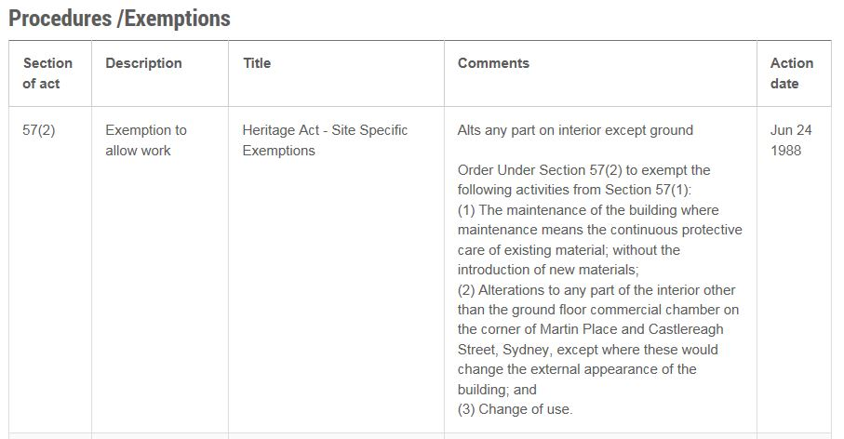

Step 4: Describe the proposal
Proposal
$ Click or tap here to enter text.
Estimated cost of proposal:

Click or tap here to enter text.
Brief description of the proposal (1-2 sentences):

Field | Explanation
Estimated cost of proposal | Include the estimated total cost of carrying out the proposed works. Applications will not be assessed without this information.
Description of the proposal | This is a legal document and you must explain proposed works by providing a general overview of intended activities. Do not only refer to attached documentation or plans.
Has development consent been granted? | If yes, please also provide in the Development Application (DA) number in the ‘DA No.’ box and the date it was approved.
Is this application consistent with the approved DA? | Indicate whether the proposed works are consistent with those works proposed in the approved DA
If no, please detail any changes | Please specify any changes to the proposed works from those approved in the DA.

Step 5: Complete landowner, applicant and Excavation Director details

Landowner
Business/Organisation name (if applicable)

Click or tap here to enter text.
Click or tap here to enter text.
Telephone
Last name
Click or tap here to enter text.
Click or tap here to enter text.
First name
Click or tap here to enter text.
Address
Date
Email
Click or tap here to enter text.
Title
Mobile

Click or tap to enter a date.
Click or tap here to enter text.
Signature
( ) Click or tap here to enter text.

Applicant
If the Landowner is also the Applicant, you do not need to complete this section.

☐ Yes ☐ No
Is the landowner also the applicant?

Business/Organisation name (if applicable)

Last name
First name
Title
Click or tap here to enter text.
Date
Signature
Email
Mobile
Telephone
Address
Click or tap to enter a date.
Click or tap here to enter text.
Click or tap here to enter text.
Click or tap here to enter text.
Click or tap here to enter text.
Click or tap here to enter text.
Click or tap here to enter text.
( ) Click or tap here to enter text.

Excavation Director
Business/Organisation name (if applicable)

Click or tap here to enter text.
Click or tap here to enter text.
Telephone
Last name
Click or tap here to enter text.
Click or tap here to enter text.
First name
Click or tap here to enter text.
Address
Date
Email
Click or tap here to enter text.
Title
Mobile

Click or tap to enter a date.
Click or tap here to enter text.
Signature
( ) Click or tap here to enter text.

Field | Explanation
Signature | This form is a legal document and so it is important that the landowner’s formal signature is included here. Lack of a signature will prevent the application from being processed.
Applicant | The applicant is the person who will be formally contacted in relation to the application. Please note, if a business/organisation name is provided, this is considered to be the applicant, and the individual identified is the contact person for the applicant.. The applicant cannot be the Excavation Director.  Note: Failure to include land owner’s consent will prevent the application from being progressed.
Excavation Director | Complete this section if the proposal involves the excavation of land, or works to building cavities, which will, or is likely to disturb archaeology.  Excavation Directors are people with professional training and extensive fieldwork experience in the investigation of relics within historical archaeological sites that have completed tertiary training in archaeology, prehistory or a related field. Excavation Directors may be consultant historical archaeologists undertaking paid professional work associated with site redevelopment projects; university employed archaeologists and/or others undertaking research investigations of historic sites. Refer to the Criteria for the Assessment of Excavation Directors to ensure you nominate a suitably qualified person.  Note: the applicant is responsible for nominating an Excavation Director for the proposed works, if the works involve archaeological excavation, and ensuring the Excavation Director section of the form is complete before submitting. Failure to include documentation of the Excavation Director will prevent the application being progressed.

Step 6: Attach the documents
Check that you have included the following:
- The completed Works Application form
- Plans/drawings describing your proposal. The plans/drawings should clearly show the proposed works. Including any proposed conservation, activation or stabilisation works; any proposed demolition, removal, destruction or excavation, what will remain without change, and what you propose to construct, create, plant or alter. The plans should show the relationship of your proposal to the site boundaries and existing site features. If there are multiple plans please include a plan schedule.
- A Heritage Impact Statement – information to assist you in preparing a Heritage Impact Statement is available in the guideline Statements of Heritage Impact. If an endorsed CMP exists, please confirm compliance of the proposed works against the policies of the CMP.
- Excavation Directors resume or CV – if your proposal will include archaeological excavation.
- An Archaeological Assessment – if the proposal involves the excavation of land, or works to building cavities, which will, or is likely to disturb archaeology.
- An Archaeological Research Design (ARD) – if archaeology is proposed and an ARD does not already form part of the Heritage Impact Statement.
- A copy of the notice of determination and stamped plans from council - if you are applying after an Integrated Development consent.

Step 7: Check and submit the application

Final check |  | Please tick | Office use
Are all fields in the form complete? |  | ☐ | ☐
Is the item on the SHR or subject to an IHO? |  | ☐ | ☐
Has the SHR number and location details been provided?
Have you paid the application fee or included your payment details? |  | ☐ | ☐
If you paid via direct deposit, have you attached a receipt or proof of payment? |  | ☐ | ☐
Have you provided plans/drawings indicating the location and extent of the proposed works? Digital copies of all documents are preferred. | Hard copies will only be excepted in special circumstances. Please contact us if you cannot supply digital copies of all documents. | ☐ | ☐
Have you described your proposed works and included the estimated cost of the proposal? |  | ☐ | ☐
Have you included the contact details and consent of the landowner? |  | ☐ | ☐
Have you included the contact details and signature of the applicant? |  | ☐ | ☐
Have you attached a copy of the Heritage Impact Statement? |  | ☐ | ☐
If you are applying after an integrated development approval, have you included a copy of the notice of determination and stamped plans from council? |  | ☐ | ☐
If archaeological excavation is proposed, have you:
Attached an Archaeological Research Design? |  | ☐ | ☐
Included the details of the Excavation Director, their signature, and resume or CV? |  | ☐ | ☐

The completed form and related documents should be emailed to:
PlanningLodgements@cityofsydney.nsw.gov.au

What happens next?
An officer will review your application. To avoid confusion and delays, it is important that the application form and documents are submitted together. Applications cannot progress until they are considered to be complete.
When your application is ready to proceed, the City of Sydney will request payment. The application will only be lodged once payment is received.
An officer may seek further information to enable proper assessment. In this case, you will have 14 calendar days to provide the additional information. If you do not submit the required information within that time, you will be asked to withdraw your application and re-submit when all the required information is available to be submitted.

Further information
If you wish to clarify any of the application requirements, please contact the City of Sydney on on 02 9265 9333.

